Name

Mathematics Extension 1 Year 11
Inverse Trigonometric
Functions

Book 1 |  | Version: 261028  Feedback:  https://MrDingMaths.com
Contents
Syllabus Content 2
Learning Intention 9

Syllabus Content
ME1-12-03 solves problems involving inverse trigonometric functions
Definitions of inverse trigonometric functions
- Graph $y=\sin{x}$, $y=\cos{x}$ and $y=\tan{x}$, for $-2π≤x≤2π$ using graphing applications and recognise that these three functions fail the horizontal line test
- Examine possible domain restrictions of $y=\sin{x}$, $y=\cos{x}$ and $y=\tan{x}$ to obtain the corresponding inverse functions using graphing applications
- Define $\sin^{-1}x$ or $\arcsin{x}$ to be the inverse function of $y=\sin{x}$ restricted to $-\frac{π}{2}≤x≤\frac{π}{2}$, and determine the domain and range of${y=sin}^{-1}x$
- Define $\cos^{-1}x$ or $\arccos{x}$ to be the inverse function of $y=\cos{x}$ restricted to $0≤x≤π$, and determine the domain and range of${y=cos}^{-1}x$
- Define $\tan^{-1}x$ or $\arctan{x}$ to be the inverse function of $y=\tan{x}$ restricted to $-\frac{π}{2}<x<\frac{π}{2}$, and determine the domain and range of${y=tan}^{-1}x$
- Evaluate and simply expressions, and prove results using the definitions of $\sin^{-1}{x}$, $\cos^{-1}{x}$ and $\tan^{-1}{x}$
Graphs of inverse trigonometric functions
- Graph $y=\sin{x}$ for $-\frac{π}{2}≤x≤\frac{π}{2}$, then use a reflection in $y=x$ to graph $y=\sin^{-1}{x}$ with and without graphing applications
- Graph $y=\cos{x}$ for $0≤x≤π$, then use a reflection in $y=x$ to graph $y=\cos^{-1}{x}$ with and without graphing applications
- Graph $y=\tan{x}$ for $-\frac{π}{2}<x<\frac{π}{2}$, then use a reflection in $y=x$ to graph $y=\tan^{-1}{x}$ with and without graphing applications
- Classify ${y=sin}^{-1}{x}$, $y=\cos^{-1}{x}$ and $y=\tan^{-1}{x}$ as odd, even, or neither odd nor even
- Examine the properties $\sin^{-1}\left(-x\right)=-\sin^{-1}{x}$, $\cos^{-1}\left(-x\right)=π-\cos^{-1}{x}$, $\tan^{-1}\left(-x\right)=-\tan^{-1}{x}$ and $\cos^{-1}x+\sin^{-1}x=\frac{π}{2}$ using graphing applications and prove them algebraically
- Use the properties $\sin^{-1}\left(-x\right)=-\sin^{-1}{x}$, $\cos^{-1}\left(-x\right)=π-\cos^{-1}{x}$, $\tan^{-1}\left(-x\right)=-\tan^{-1}{x}$and $\cos^{-1}x+\sin^{-1}x=\frac{π}{2}$ to solve problems, simplify expressions and prove results
- Graph the composite functions $y=\sin{(\sin^{-1}}{x)}$, $y=\cos{(\cos^{-1}}{x)}$ and $y=\tan{(\tan^{-1}}{x)}$ by considering their domains and ranges
- Examine the graphs of the composite functions $y=\sin{(\sin^{-1}}{x)}$, $y=\cos{(\cos^{-1}}{x)}$ and $y=\tan{(\tan^{-1}}{x)}$, establish the values of $x$ for which the formulas $\sin{(\sin^{-1}}{x)}=x$, $\cos{(\cos^{-1}}{x)}=x$ and $\tan{(\tan^{-1}}{x)}=x$ are true, and apply the formulas to solve problems, simplify expressions and prove results
- Graph the composite functions ${y=sin}^{-1}{(sin}{x)}$, ${y=cos}^{-1}{(cos}{x)}$ and ${y=tan}^{-1}{(tan}{x)}$ by considering their domains and ranges
- Examine the graphs of the composite functions ${y=sin}^{-1}{(sin}{x)}$, ${y=cos}^{-1}{(cos}{x)}$ and ${y=tan}^{-1}{(tan}{x)}$, establish the values of $x$ for which the formulas $\sin^{-1}{(sin}{x)}=x$, $\cos^{-1}{(cos}{x)}=x$and $\tan^{-1}{(tan}{x)}=x$ are true, and apply the formulas to solve problems, simplify expressions and prove results
- Use graphing applications to explore reflections, translations and dilations of the functions $f\left(x\right)=\sin^{-1}{x}$, $f\left(x\right)=\cos^{-1}{x}$ and $f(x)=\tan^{-1}{x}$, and confirm that the principles of transformations hold for the inverse trigonometric functions
- Apply the principles of transformations to inverse trigonometric functions to determine the function rule and graph the function, finding the domain and range of the transformed graph and determining any intercepts and asymptotes where appropriate

Inverse Trigonometric Functions

- Review
- Recall exact values of trigonometric functions in radians.

$$\sin\left(\frac{5π}{3}\right)$$ | $$\tan\left(\frac{2π}{3}\right)$$ | $$\cos\left(\frac{5π}{4}\right)$$
$$\sin\left(\frac{7π}{6}\right)$$ | $$\cos\left(\frac{5π}{6}\right)$$ | $$\sin\left(-\frac{π}{3}\right)$$
$$\tan\left(-\frac{π}{6}\right)$$ | $$\cos\left(-\frac{π}{4}\right)$$ | $$\sin\left(-\frac{7π}{6}\right)$$

- Inverse of the trigonometric functions
P
Function | Inverse
$$\sin{(x)}$$  $$\cos{(x)}$$  $$\tan{(x)}$$ | $\sin^{-1}{(x)}$ or $\arcsin\left(x\right)$  $\cos^{-1}{(x)}$ or $\arccos\left(x\right)$  $\tan^{-1}{(x)}$ or $\arctan\left(x\right)$
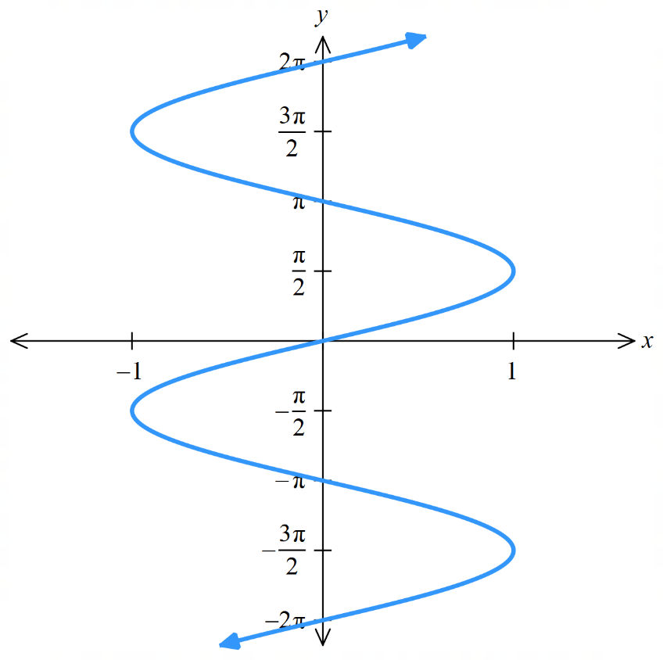
$$y=\sin{x}$$  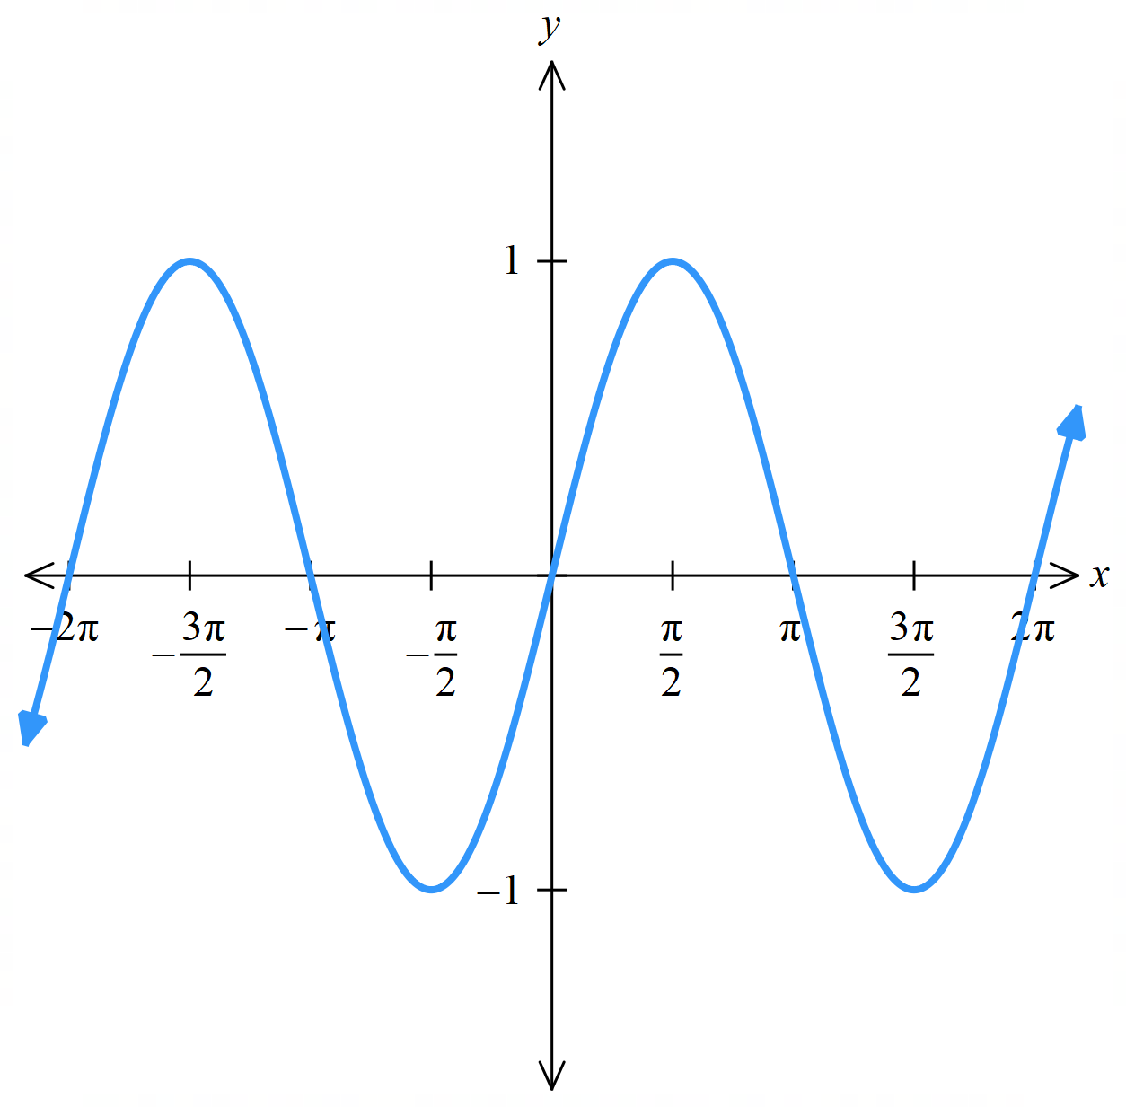  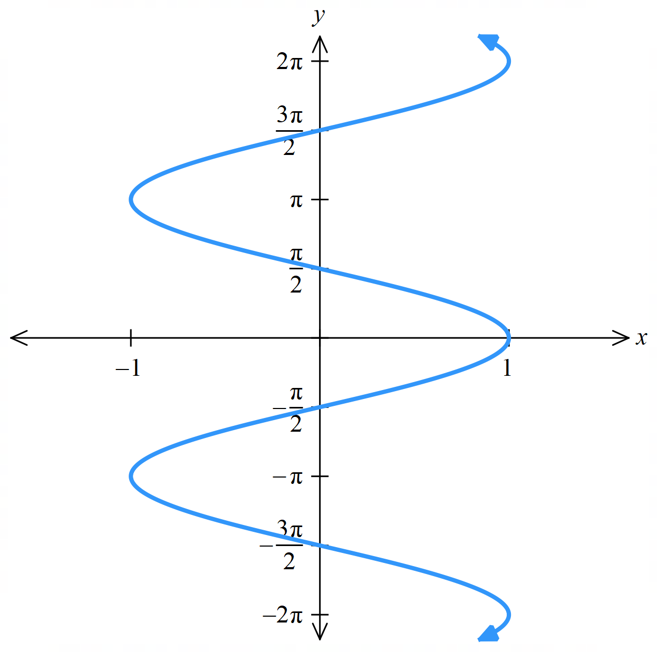 | $$x=\sin{y}$$
$$y=\cos{x}$$  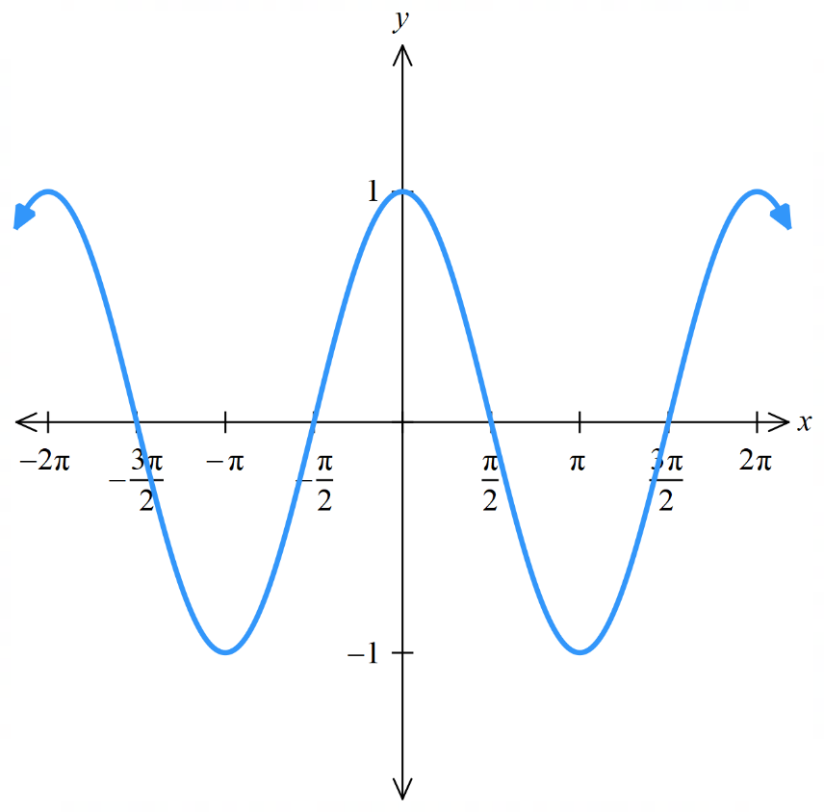  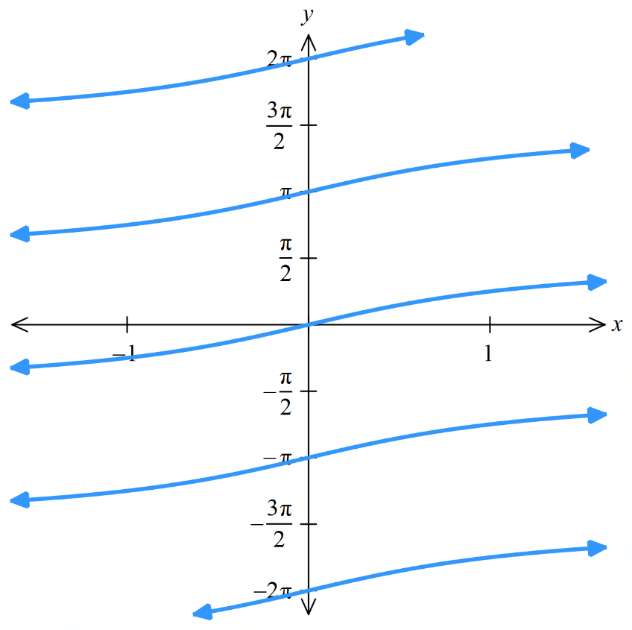 | $$x=\cos{y}$$
$$y=\tan{x}$$  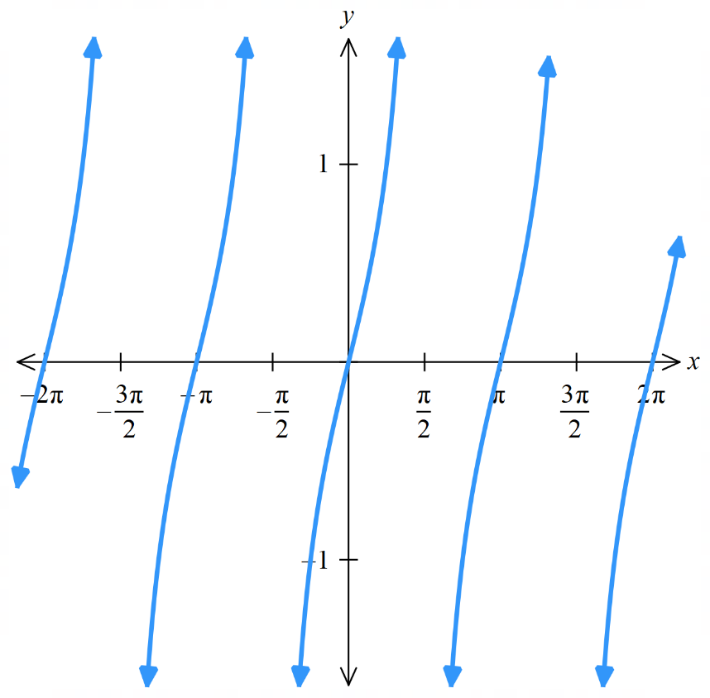 | $$x=\tan{y}$$

- Definition of the inverse trigonometric functions $sin^{-1} x$, $cos^{-1} x$, $tan^{-1} x$
- The trigonometric functions fail the horizontal line test;
their inverse relations aren't functions.
- We restrict the domain of trigonometric functions so that the curve is strictly increasing, creating inverse trigonometric functions.
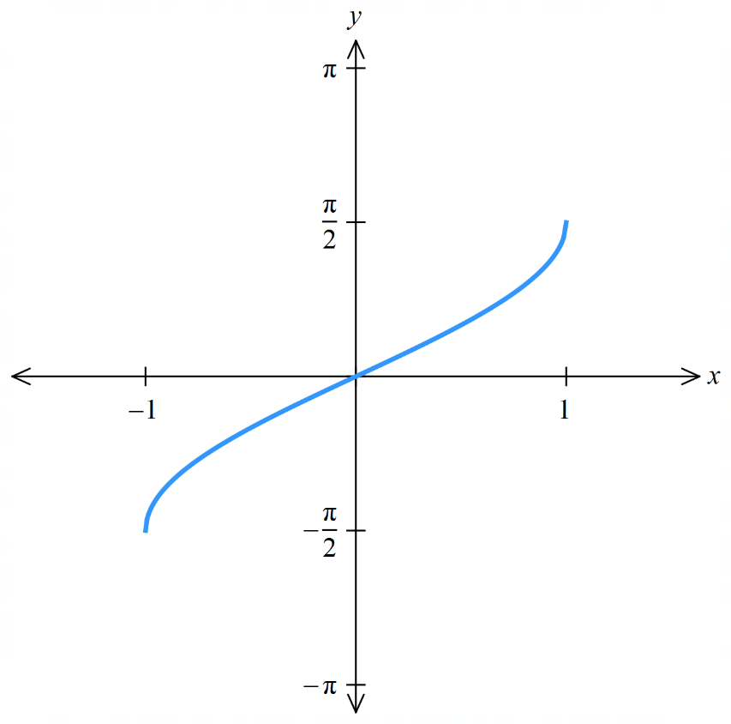
- The domain restrictions were defined by mathematicians to be as simple as possible.
$y=\sin{x};$ $x∈\left[-\frac{π}{2},\frac{π}{2}\right]$  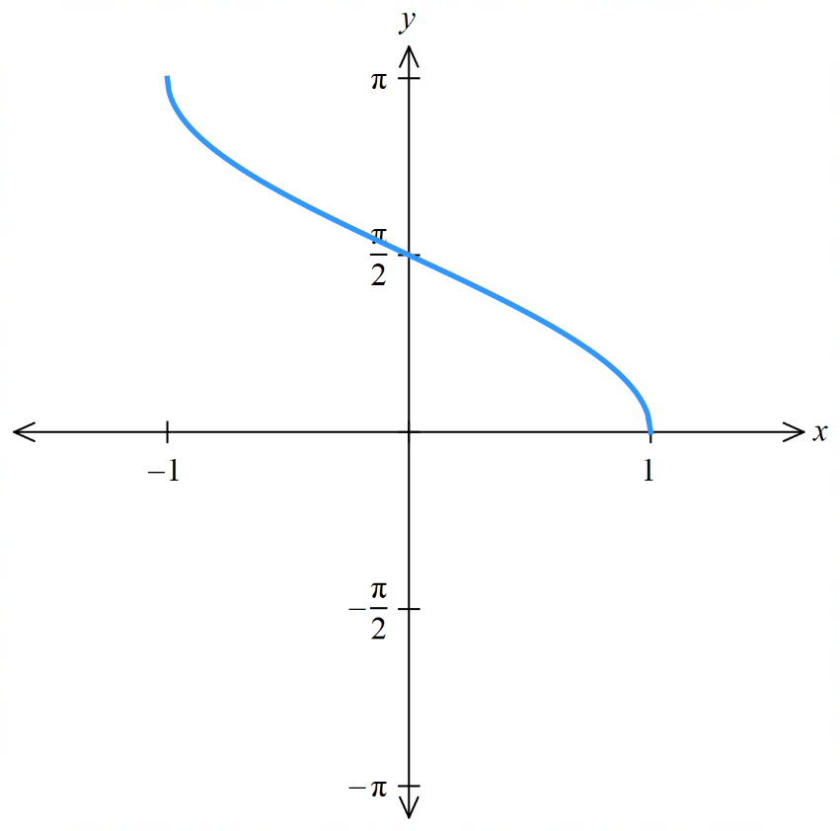 |  | $$y=\sin^{-1}{x}$$
$y=\cos{x}$; $x∈\left[0,π\right]$  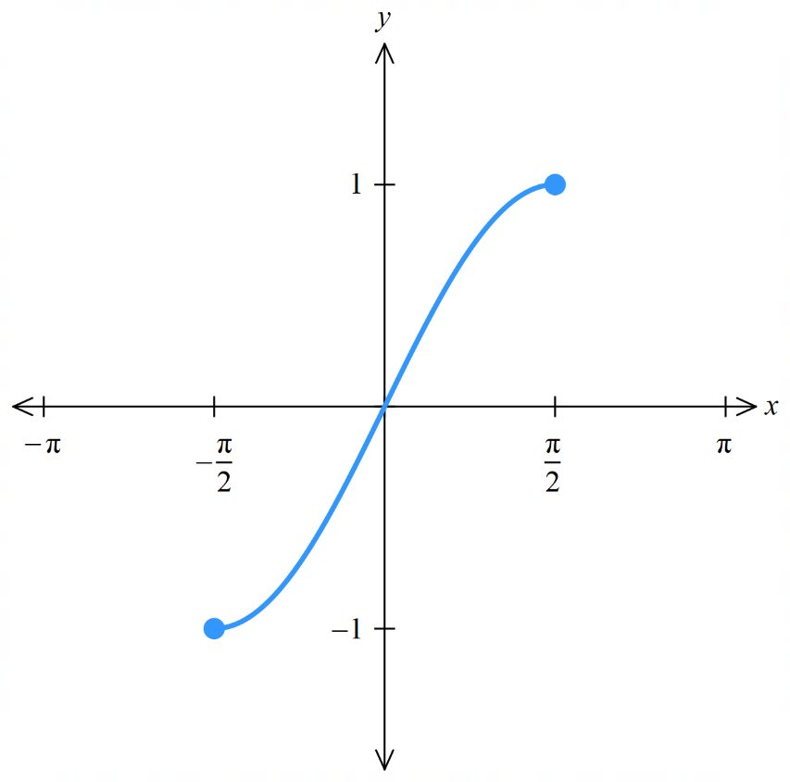  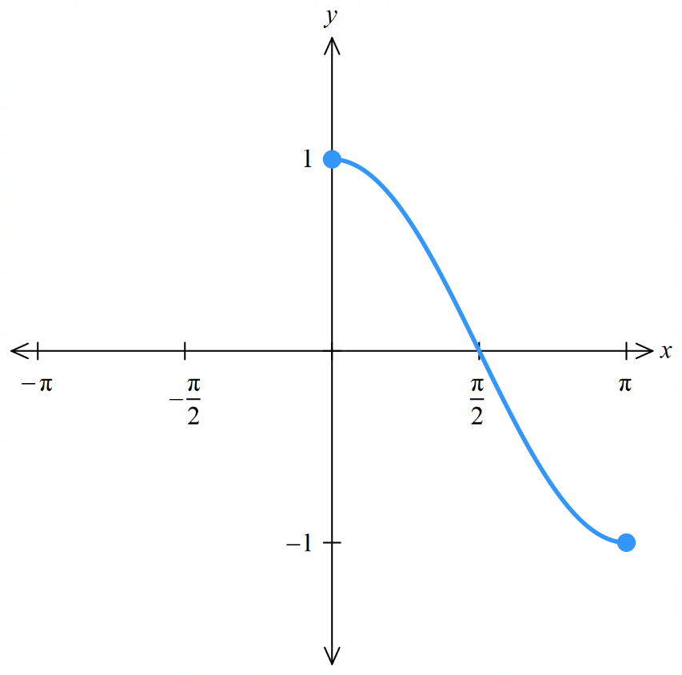  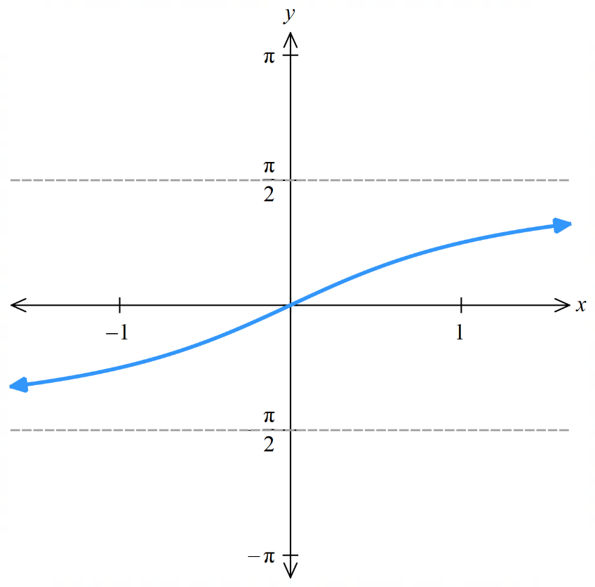 |  | $$y=\cos^{-1}{x}$$
$y=\tan{x}$; $x∈\left[-\frac{π}{2},\frac{π}{2}\right]$  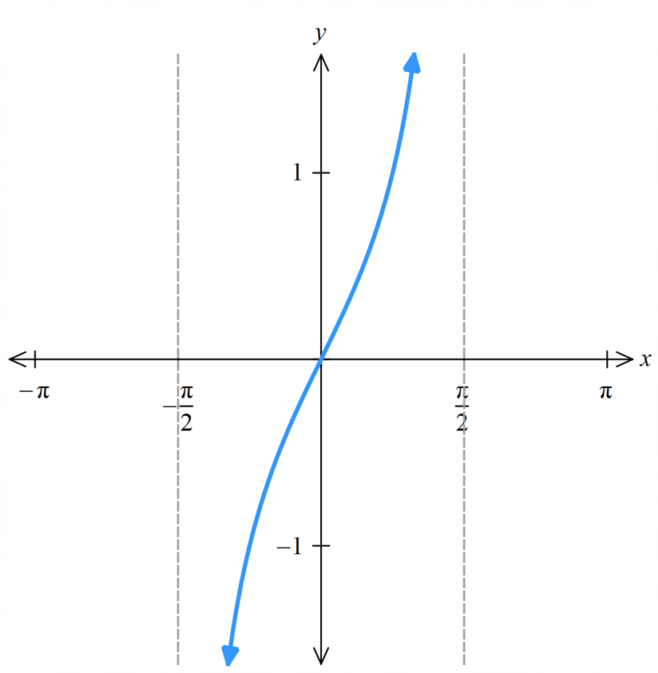 |  | $$y=\tan^{-1}{x}$$
- Identify properties of the inverse trigonometric functions.
Sketch: $y=\sin^{-1}{x}$  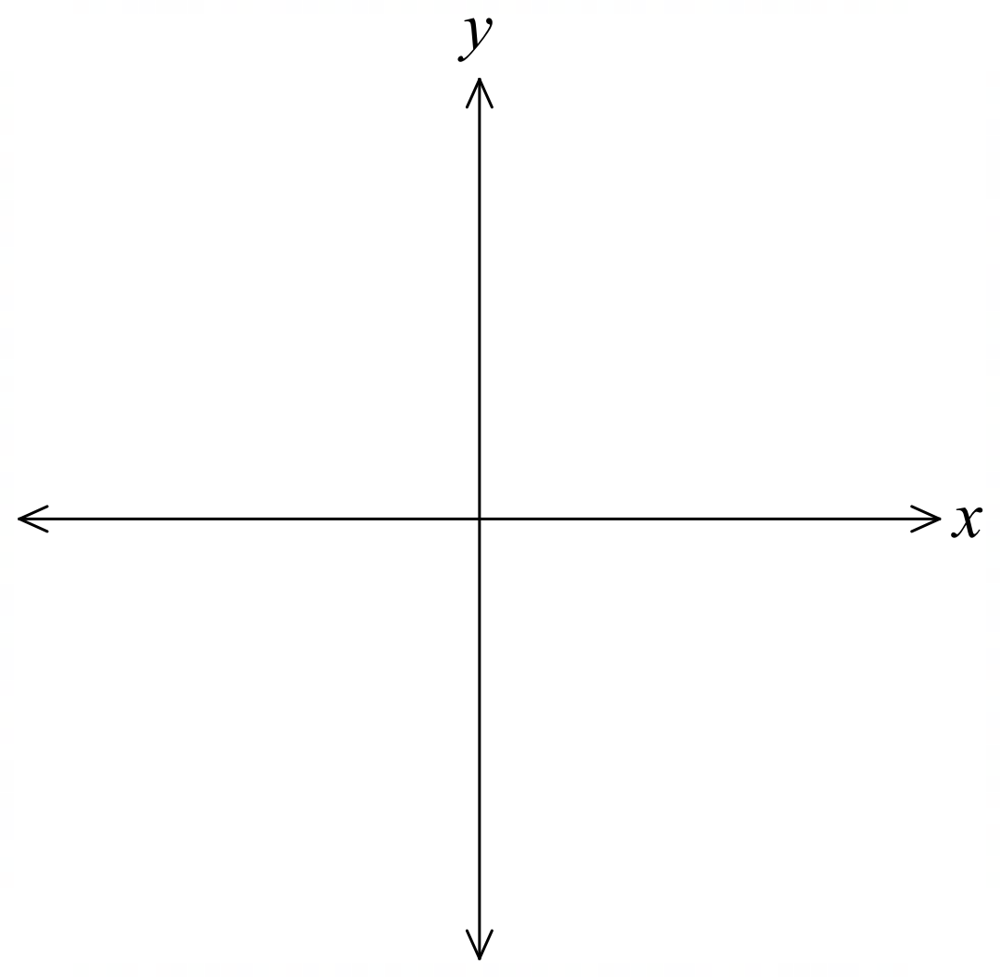  Domain:  Range:  Asymptotes?  Odd | Even | Neither  Increasing | Decreasing | Sketch: $y=\cos^{-1}{x}$  Domain:  Range:  Asymptotes?  Odd | Even | Neither  Increasing | Decreasing |  | Sketch: $y=\tan^{-1}{x}$  Domain:  Range:  Asymptotes?  Odd | Even | Neither  Increasing | Decreasing

- Evaluating inverse trigonometric functions
- Determine the reference angle, if it exists.
- Find the angle in the range of the inverse function.
We always work in radians.

- Example Evaluate inverse trigonometric functions.
Evaluate $\cos^{-1}\left(-\frac{1}{2}\right)$  1. Reference angle is $\frac{π}{3}$  2. Since cos is negative  $$∴\cos^{-1}\left(-\frac{1}{2}\right)=π-\frac{π}{3}$$  $$=\frac{2π}{3}$$  Note: we do not consider $π+\frac{π}{3}$ as this is not in the range $\left[0,2π\right]$ | Evaluate $\tan^{-1}\left(1\right)$  1. Reference angle is $\frac{π}{4}$  2. Since tan is positive,  $$tan^{-1}\left(1\right)=\frac{π}{4}$$  Note: we do not consider $π+\frac{π}{4}$ as this is not in the range $\left[-\frac{π}{2},\frac{π}{2}\right]$ | Evaluate $\sin^{-1}\left(1.2\right)$  1.2 is not in the domain of $\left[-\frac{π}{2},\frac{π}{2}\right],$ $∴$ undefined.

- Practice
Evaluate:
$$\sin^{-1}\left(\frac{\sqrt{3}}{2}\right)$$  $$\frac{π}{3}$$ | $$\sin^{-1}\left(-\frac{1}{2}\right)$$  $$-\frac{π}{6}$$
$$\cos^{-1}\left(3\right)$$  undefined | $$\tan^{-1}\left(-\frac{1}{\sqrt{3}}\right)$$  $$-\frac{π}{6}$$

Foundation
- Evaluate:
- $sin⁻¹ 0$  $$0$$ | - $arctan \left(-1\right)$  $$-\frac{π}{4}$$ | - $cos⁻¹ 1$  $$0$$ | - $\tan^{-1}\left(-\sqrt{3}\right)$  $$-\frac{π}{3}$$
- $\sin^{-1}\left(\frac{1}{2}\right)$  $$\frac{π}{6}$$ | - $\sin^{-1}\left(-\frac{\sqrt{3}}{2}\right)$  $$-\frac{π}{3}$$ | - $\sin^{-1}\left(\frac{1}{2}\right)$  $$\frac{π}{6}$$ | - $\sin^{-1}\left(\frac{1}{\sqrt{2}}\right)$  $$\frac{π}{4}$$
- $arccos 1$  $$0$$ | - $\cos^{-1}\left(-\frac{1}{\sqrt{2}}\right)$  $$\frac{3π}{4}$$ | - $tan⁻¹ (-1)$  $$-\frac{π}{4}$$ | - $\cos^{-1}\left(-\frac{\sqrt{3}}{2}\right)$  $$\frac{5π}{6}$$
- $arctan 1$  $$\frac{π}{4}$$ | - $arctan \left(-\frac{1}{\sqrt{3}}\right)$  $$-\frac{π}{6}$$ | - $sin⁻¹ (-1)$  $$-\frac{π}{2}$$ | - $arcsin(2)$  $$Undefined$$
- $\sin^{-1}\left(-1\right)$  $$-\frac{π}{2}$$ | - $arccos \left(-1\right)$  $$π$$ | - $cos⁻¹ 0$  $$\frac{π}{2}$$ | - $arcsin(0.5)$  $$\frac{π}{6}$$
- $cos⁻¹ 0$  $$\frac{π}{2}$$ | - $sin⁻¹ 1$  $$\frac{π}{2}$$ | - $\cos^{-1}\left(\frac{1}{\sqrt{2}}\right)$  $$\frac{π}{4}$$ | - $arccos(-3)$  $$Undefined$$
- $arctan 0$  $$0$$ | - $tan⁻¹ 0$  $$0$$ | - $\tan^{-1}\left(\frac{1}{\sqrt{3}}\right)$  $$\frac{π}{6}$$ | - $arccos(0.5)$  $$\frac{π}{3}$$

- Evaluate, using a calculator. Answer to 3 d.p. Remember to be in in radians mode.
- $cos⁻¹ 0.123$  1.447 | - $arccos \left(-0.123\right)$  1.694 | - $\sin^{-1}\left(\frac{2}{3}\right)$  0.730
- $arcsin \left(-\frac{2}{3}\right)$  –0.730 | - $tan⁻¹ 5$  1.373 | - $arctan \left(-5\right)$  –1.373

Development
- Evaluate:
- $cos\left(\sin^{-1}\left(0\right)- \cos^{-1}\left(\frac{1}{2}\right)\right)$  $$\sin^{-1}\left(0\right)= 0, \cos^{-1}\left(\frac{1}{2}\right)=\frac{π}{3}$$  $$cos\left(0 -\frac{π}{3}\right)= cos\left(-\frac{π}{3}\right)= cos\left(\frac{π}{3}\right)=\frac{1}{2}$$ | - $tan\left(\sin^{-1}\left(1\right)+ \sin^{-1}\left(\frac{1}{2}\right)\right)$  $$\sin^{-1}\left(1\right)=\frac{π}{2}, \sin^{-1}\left(\frac{1}{2}\right)=\frac{π}{6}$$  $$tan\left(\frac{π}{2}+\frac{π}{6}\right)= tan\left(\frac{2π}{3}\right)= -\sqrt{3}$$
- $cos\left(\cos^{-1}\left(-\frac{1}{2}\right)- \sin^{-1}\left(-\frac{1}{2}\right)\right)$  $$\cos^{-1}\left(-\frac{1}{2}\right)=\frac{2π}{3}, \sin^{-1}\left(-\frac{1}{2}\right)= -\frac{π}{6}$$  $$\cos\left(\frac{2π}{3}- \left(-\frac{π}{6}\right)\right)=\cos\left(\frac{2π}{3}+\frac{π}{6}\right)$$  $$= cos(5π/6) = -\frac{\sqrt{3}}{2}$$ | - $sin\left(\tan^{-1}\left(-\frac{1}{\sqrt{3}}\right)- \tan^{-1}\left(-\sqrt{3}\right)\right)$  $$\tan^{-1}\left(-\frac{1}{\sqrt{3}}\right)= -\frac{π}{6}, \tan^{-1}\left(-\sqrt{3}\right)= -\frac{π}{3}$$  $$sin\left(-\frac{π}{6}- \left(-\frac{π}{3}\right)\right)= sin\left(-\frac{π}{6}+\frac{π}{3}\right)$$  $$= sin\left(\frac{π}{6}\right)=\frac{1}{2}$$

- By swapping $x$ and $y$, find the inverse of these functions.
- $y=1+cos x$  $$y=1+\cos{x}$$  $$x=1+cos y$$  $$x-1=\cos{y}$$  $$y=\cos^{-1}\left(x-1\right)$$ | - $y=1-2sin\left(\frac{x}{3}\right)$  $$x=1-2sin\left(\frac{y}{3}\right)$$  $$x-1=-2sin\left(\frac{y}{3}\right)$$  $$\frac{1 - x}{2} = sin\left(\frac{y}{3}\right)$$  $$\frac{y}{3}= sin^{-1}\left(\frac{1 -x}{2}\right)$$  $$y = 3sin^{-1}\left(\frac{1 - x}{2}\right)$$

  - Sketch $y=\sin^{-1}{x}$ and $y=\cos^{-1}{x}$ on the same set of axes.
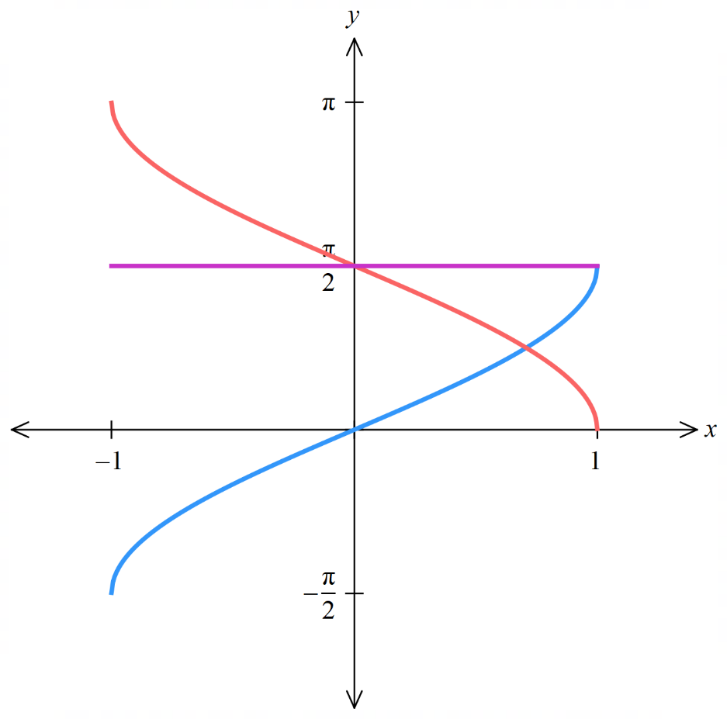
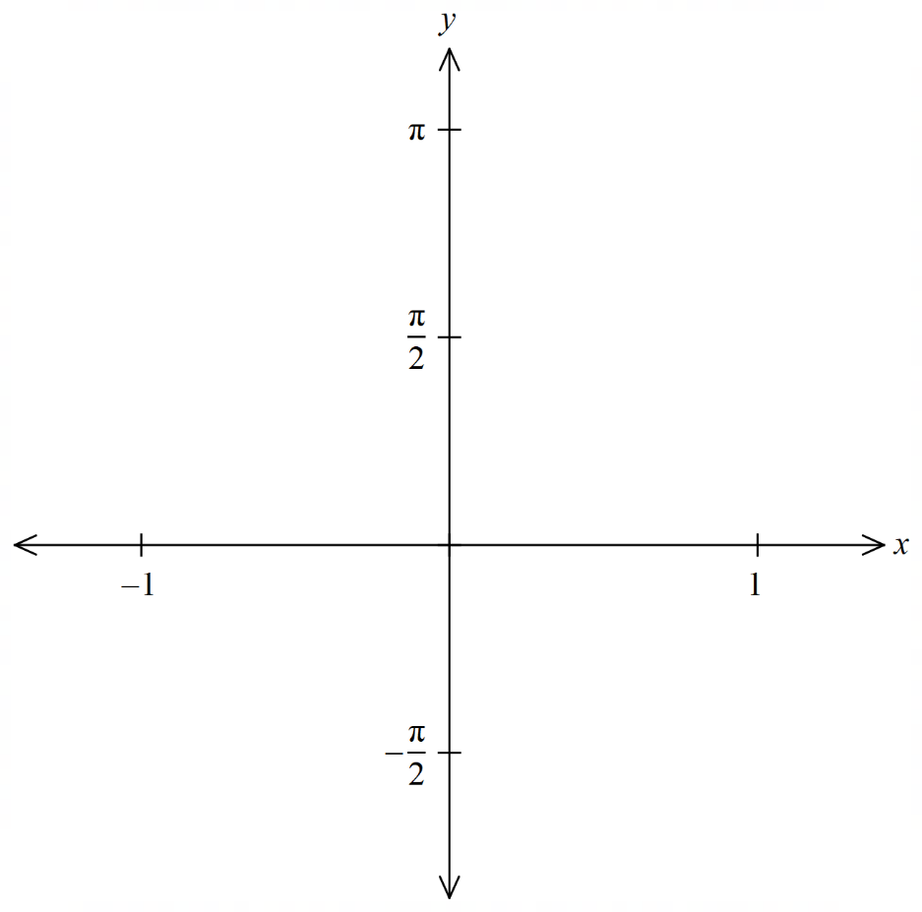

  - By adding ordinates, sketch the graph of $y=\sin^{-1}{x}+\cos^{-1}{x}$

Inverse Trigonometric Identities and Compositions

- Inverse trigonometric functions
$$y=\sin^{-1}{x}$$ | $$y=\cos^{-1}{x}$$ | $$y=\tan^{-1}{x}$$  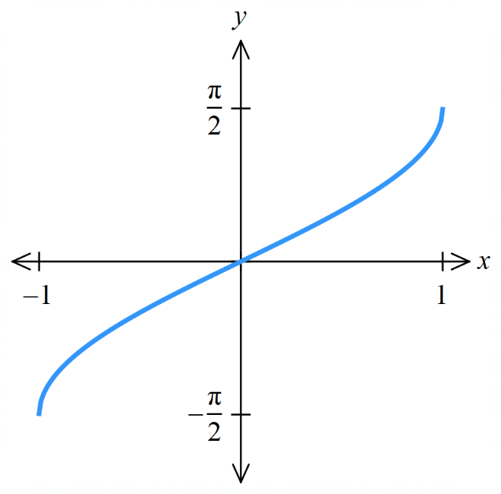  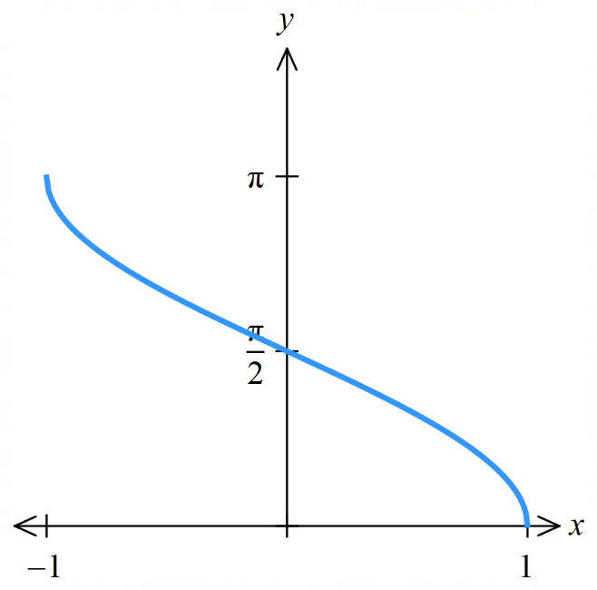  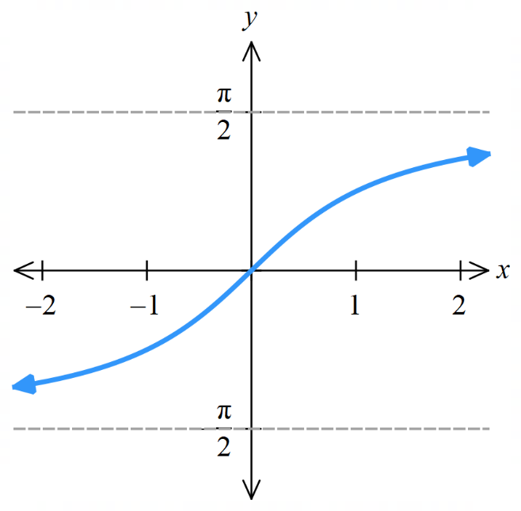

- Inverse Trigonometric Identities
$\sin^{-1}\left(-x\right)=-\sin^{-1}{x}$, because $\sin\left(-x\right)=-\sin{x}$
$\cos^{-1}\left(-x\right)=π-\cos^{-1}{x}$, because $\cos{(-x)}=\cos\left(π-x\right)$.
$\tan^{-1}{(-x)}=-\tan^{-1}{x}$, because $\tan\left(-x\right)=-\tan{x}$
$\sin^{-1}{x}+\cos^{-1}{x}=$ $\frac{π}{2}$, because $\cos{x}=\sin\left(\frac{π}{2}-x\right)$.

- Example Simplify expressions using inverse trigonometric identities.
$$\sin^{-1}\left(-x\right)+\sin^{-1}\left(x\right)$$  $$=-\sin^{-1}\left(x\right)+\sin^{-1}\left(x\right)$$  $$=0$$ | $$\sin^{-1}\left(-x\right)+\cos^{-1}\left(-x\right)$$  $$=\frac{π}{2}$$

- Practice
Simplify:
$$\tan^{-1}\left(-x\right)+\tan^{-1}\left(x\right)$$  $$0$$ | $$\cos^{-1}\left(x\right)-\sin^{-1}\left(-x\right)$$  $$\frac{π}{2}$$ | $$\cos^{-1}\left(-x\right)-π$$  $$-\cos^{-1}{x}$$
- Evaluating the composition of Inverse Trigonometric Functions
1. Let $α$ be the inner function.
2. Rearrange $α$.
3. Identify quadrant using range of $α$and sign of the trigonometric function.
4. Draw a right-angled triangle and find missing side.
5. Evaluate.

- Example Find the exact value of composite inverse trigonometric functions.
$$Evaluate \tan\left(\sin^{-1}\left(-\frac{1}{5}\right)\right)$$  $$α$$  $$-1$$  $$5$$  $$\sqrt{24}$$  $$1. Let α=\sin^{-1}\left(-\frac{1}{5}\right)$$  $$2. \sin{α}=-\frac{1}{5}$$  $$3. -\frac{π}{2}≤α≤\frac{π}{2}, \sin{α<0}, ∴Q4$$  $$4.$$  $$5. \tan{α}=-\frac{1}{\sqrt{24}}=-\frac{1}{2\sqrt{6}}=-\frac{\sqrt{6}}{12}$$ | $$Evaluate \sin\left(\cos^{-1}\left(-\frac{4}{5}\right)\right)$$  $$α$$  $$3$$  $$5$$  $$-4$$  $$1. Let α=\cos^{-1}\left(-\frac{4}{5}\right)$$  $$2. \cos{α}=-\frac{4}{5}$$  $$3. 0≤α≤π, \cos{α<0}, ∴Q2$$  $$4.$$  $$5. \sin{α}=\frac{3}{5}$$

- Practice
$$Evaluate \cos\left(\sin^{-1}\left(-\frac{1}{4}\right)\right)$$  1.  2.  2.  4.  5.  $$\frac{\sqrt{15}}{4}$$ | $$Evaluate \tan\left(\cos^{-1}\left(-\frac{2}{5}\right)\right)$$  $$-\frac{\sqrt{21}}{2}$$

Foundation
- Evaluate, using the identities.
- $\cos^{-1}\left(-1\right)+ \cos^{-1}1$  $$π$$ | - $sin⁻¹1 + \sin^{-1}\left(-1\right)$  $$0$$ | - $tan⁻¹1 + \tan^{-1}\left(-1\right)$  $$0$$
- $\sin^{-1}\left(\frac{1}{2}\right)+ \cos^{-1}\left(\frac{1}{2}\right)$  $$\frac{π}{2}$$ | - $\cos^{-1}\left(\frac{\sqrt{3}}{2}\right) + \sin^{-1}\left(\frac{\sqrt{3}}{2}\right)$  $$\frac{π}{2}$$ | - $\sin^{-1}\left(\frac{1}{\sqrt{2}}\right)+ \cos^{-1}\left(\frac{1}{\sqrt{2}}\right)$  $$\frac{π}{2}$$

- Use a right-angled triangle to find the exact value of these expressions.
- $sin\left(cos^{-1}\left(\frac{3}{5}\right)\right)$  Let $α=\cos^{-1}\left(\frac{3}{5}\right)$  $$α=\cos\left(\frac{3}{5}\right)$$  Quadrant: ……  $$\frac{4}{5}$$ | - $tan\left(\sin^{-1}\left(\frac{5}{13}\right)\right)$  $$\frac{5}{12}$$ | - $cos\left(\sin^{-1}\left(\frac{2}{3}\right)\right)$  $$\frac{\sqrt{5}}{3}$$
- $sin\left(cos^{-1}\left(-\frac{15}{17}\right)\right)$  $$\frac{8}{17}$$ | - $cos\left(\tan^{-1}\left(-\frac{1}{3}\right)\right)$  $$\frac{3\sqrt{10}}{10}$$ | - $tan\left(\cos^{-1}\left(-\frac{3}{4}\right)\right)$  $$-\frac{\sqrt{7}}{3}$$
- $\tan\left(-\sin^{-1}\left(\frac{1}{5}\right)\right)$  $$-\frac{\sqrt{6}}{12}$$ | - $cos\left(\tan^{-1}\left(\frac{1}{3}\right)\right)$  $$\frac{3\sqrt{10}}{10}$$ | - $sin\left(\cos^{-1}\left(-\frac{3}{5}\right)\right)$  $$\frac{4}{5}$$

Development
- Consider this triangle.
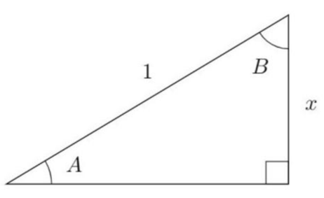
  - Find an expression for $A$ in terms of $x$.

$$\sin{A}=x$$
$$A=\sin^{-1}{x}$$
  - Find a similar expression for $B$ in terms of $x$.
Similarly, $B=\cos^{-1}{x}$
  - Deduce that $\sin^{-1}{x}+\cos^{-1}{x}=$ $\frac{π}{2}$
Since $A+B=$ $\frac{π}{2}$ (angle sum of a triangle)
$$\sin^{-1}{x}+\cos^{-1}{x}=\frac{π}{2}$$

- Find the exact value of:
- $sin^{-1}\left(-\frac{1}{2}\right)+ cos^{-1}\left(-\frac{1}{2}\right)$  $$\frac{π}{2}$$ | - $sin\left(cos^{-1}0\right)$  $$\cos^{-1}0 =\frac{π}{2}$$  $$sin\left(\frac{π}{2}\right)= 1$$ | - $cos^{-1}\left(sin\left(\frac{π}{3}\right)\right)$  $$sin\left(\frac{π}{3}\right)=\frac{\sqrt{3}}{2}$$  $$\cos^{-1}\left(\frac{\sqrt{3}}{2}\right)=\frac{π}{6}$$
- $sin\left(cos^{-1}\left(-\frac{\sqrt{3}}{2}\right)\right)$  $$\cos^{-1}\left(-\frac{\sqrt{3}}{2}\right)=\frac{5π}{6}$$  $$sin\left(\frac{5π}{6}\right)=\frac{1}{2}$$ | - $cos\left(2tan^{-1}\left(-1\right)\right)$  $$tan⁻¹(-1) = -\frac{π}{4}$$  $$cos\left(2\left(-\frac{π}{4}\right)\right)= cos\left(-\frac{π}{2}\right)= 0$$ | - $arctan\left(\sqrt{6}sin\left(\frac{π}{4}\right)\right)$  $$sin\left(\frac{π}{4}\right)=\frac{1}{\sqrt{2}}$$  $$\sqrt{6}\left(\frac{1}{\sqrt{2}}\right)=\frac{\sqrt{6}}{\sqrt{2}}= \sqrt{3}$$  $$arctan\left(\sqrt{3}\right)=\frac{π}{3}$$

- HSC Extension 1 Sample Question Band 4
Determine the exact value of
$$\sin^{-1}\left(\frac{\sqrt{3}}{2}\right)-\sin^{-1}\left(-\frac{\sqrt{3}}{2}\right)-\cos^{-1}\left(-\frac{1}{2}\right)$$

$$=\frac{π}{3}-\left(-\frac{π}{3}\right)-\frac{2π}{3}=0$$

  - Show that $\cos\left(\sin^{-1}{x}\right)=\sqrt{1-x^{2}}$.
Let $α=\sin^{-1}{x}$
$$\sin{α}=x$$
Using a right-angled triangle
H: $1$, O: $x$, $A:$ $\sqrt{1-x^{2}}$
$$∴\cos{α}=\frac{A}{H}=\sqrt{1-x^{2}}$$

  - Hence sketch the graph of $y=\cos\left(\sin^{-1}{x}\right)$
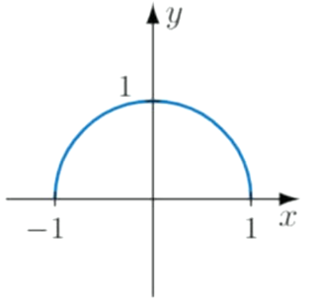

- Sketch these graphs using your knowledge of transformations.
- $y=\sin^{-1}\left(\left|x\right|\right)$  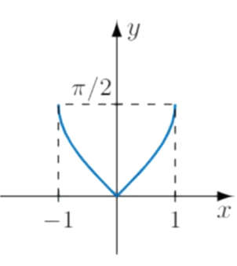 | - $y=\cos^{-1}\left(\left|x\right|\right)$  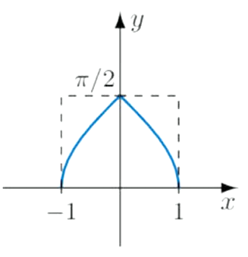 | - $y=\tan^{-1}\left(\left|x\right|\right)$  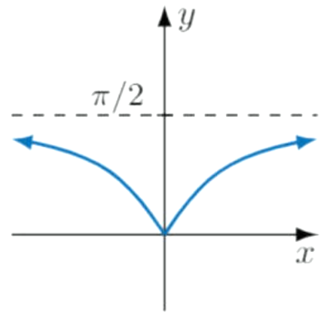

Transformations of Inverse Trigonometric Graphs

- Transformations of Inverse trigonometric functions $y=a\sin^{-1}{bx}$
$$y=\sin^{-1}{x}$$ | $$y=\cos^{-1}{x}$$ | $$y=\tan^{-1}{x}$$
$$y=a\sin^{-1}{bx}$$ | $$y=a\cos^{-1}{bx}$$ | $$y=a\tan^{-1}{bx}$$  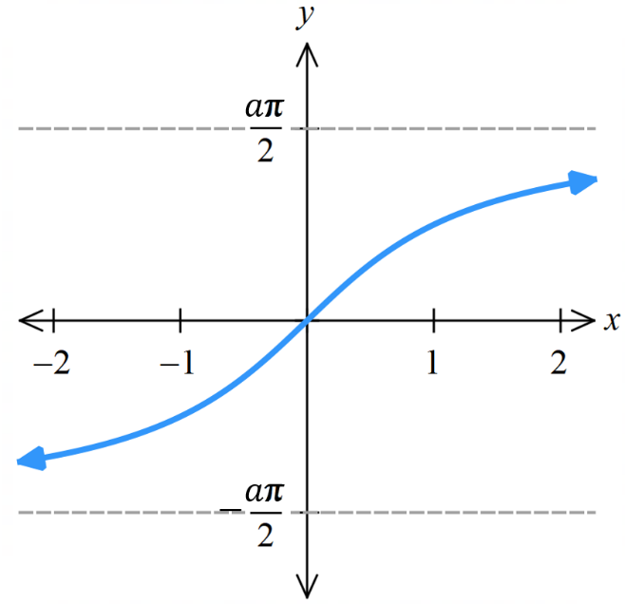  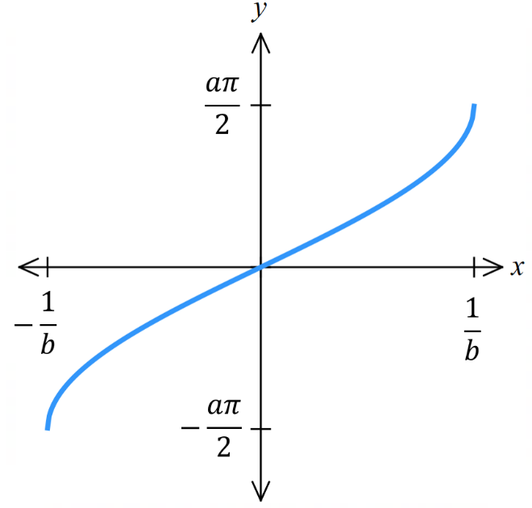  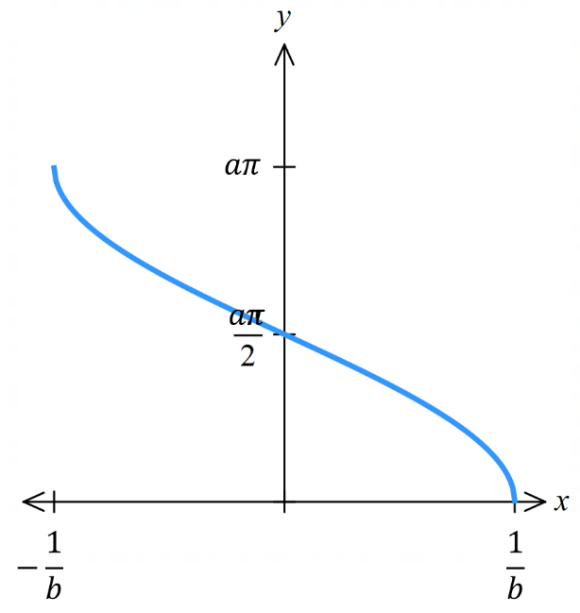

- Identify domain and range of transformed inverse trigonometric functions.
- $y=3\sin^{-1}{x}$  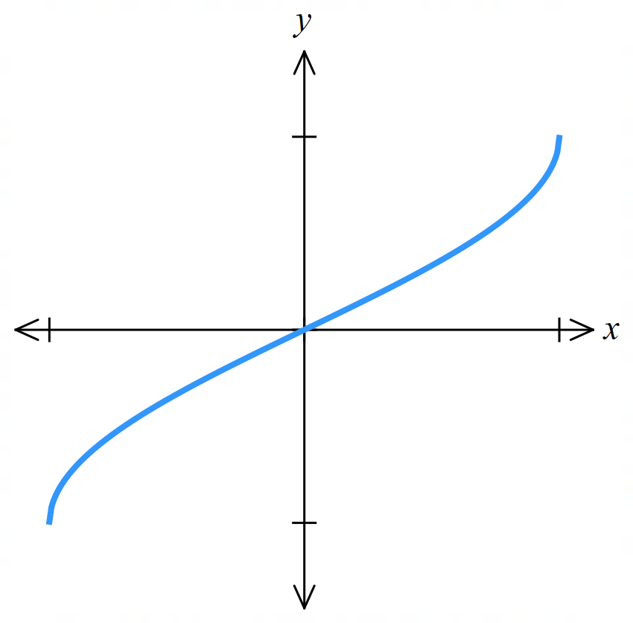 | - $y=\cos^{-1}{2x}$  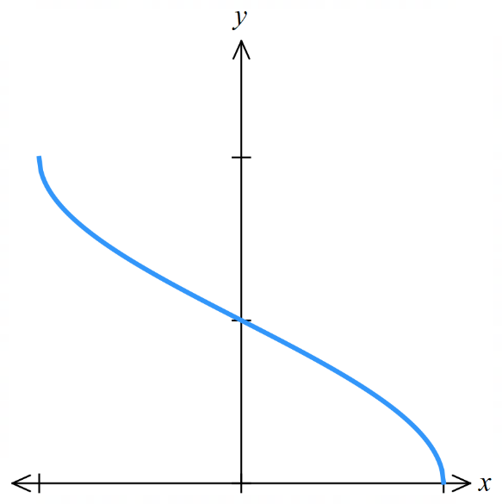 | - $y=2\sin^{-1}{3x}$
- $y=5\cos^{-1}{2x}$ | - $y=\tan^{-1}{5x}$  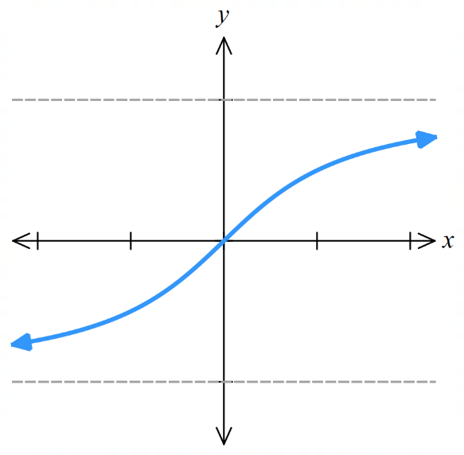 | - $y=5\tan^{-1}{x}$
- Inverse Trigonometric Function Transformations $y=\sin^{-1}{(x-d)}+c$
Horizontal translation

$$y=\sin^{-1}{(x-d)}+c$$
Vertical translation

- Sketch domain and range of transformed inverse trigonometric functions.
- $y=\sin^{-1}{x}+\frac{π}{2}$ | - $y=\cos^{-1}\left(x-1\right)$ | - $y=\sin^{-1}\left(x+1\right)$
- $y=\cos^{-1}{x}-π$ | - $y=\tan^{-1}\left(x-1\right)$ | - $y=\tan^{-1}\left(x+1\right)-\frac{π}{2}$

Foundation
- Determine the domain of these functions.
Remember that the input of an inverse sine and cosine function must be between $-1$ and $1$.
- $y=\sin^{-1}\left(2x\right)$  $$-1≤2x≤1$$  $$\left[-\frac{1}{2},\frac{1}{2}\right]$$ | - $y=\cos^{-1}\left(3x\right)$  $$\left[-\frac{1}{3},\frac{1}{3}\right]$$ | - $y=\sin^{-1}\left(x-2\right)$  $$\left[1,3\right]$$
- $y=\cos^{-1}\left(\frac{x}{5}\right)$  $$\left[-5,5\right]$$ | - $y=\sin^{-1}\left(1-x\right)$  $$\left[0,2\right]$$ | - $y=\tan^{-1}\left(x-2\right)$  $$\left(-∞,∞\right)$$

- Determine the range of these functions.
Remember that the output of an inverse sine function is $\left[-\frac{π}{2},\frac{π}{2}\right]$
and the output of an inverse cosine function is $\left[0,π\right]$
and the output of an inverse tan function is $\left[-\frac{π}{2},\frac{π}{2}\right]$.
- $y=3\sin^{-1}\left(x\right)$  $$-\frac{π}{2}≤\sin^{-1}\left(x\right)≤\frac{π}{2}$$  $$\left[-\frac{3π}{2},\frac{3π}{2}\right]$$ | - $y=3\sin^{-1}\left(5x\right)$  $$\left[-\frac{3π}{2},\frac{3π}{2}\right]$$ | - $y=2\cos^{-1}\left(x-2\right)$  $$\left[0,2π\right]$$
- $y=\frac{1}{3}\cos^{-1}\left(x\right)$  $$\left[0,\frac{π}{3}\right]$$ | - $y=-\cos^{-1}\left(x\right)$  $$\left[-π,0\right]$$ | - $y=7\tan^{-1}\left(x\right)$  $$\left(-\frac{7π}{2},\frac{7π}{2}\right)$$

  - Determine the domain of the function $y=\sin^{-1}\left(1-x\right)$ by solving $-1≤\left(1-x\right)≤1$.
$$0≤x≤2$$
  - State the range of the function.
$$-\frac{π}{2}≤y≤\frac{π}{2}$$
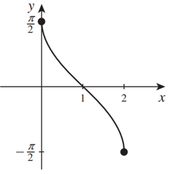
  - Complete the table and sketch the graph.
$$x$$ | $$0$$ | $$1$$ | $$2$$
$$y$$ | $$\frac{π}{2}$$ | $$0$$ | $$-\frac{π}{2}$$

Development
- Sketch by applying the appropriate reflection.
- $y=\sin^{-1}\left(-x\right)$ | - $y=\cos^{-1}\left(-x\right)$  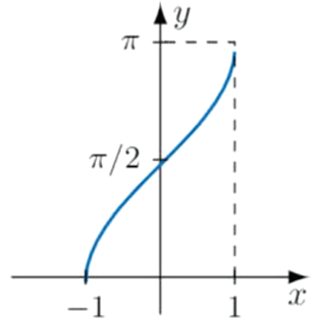  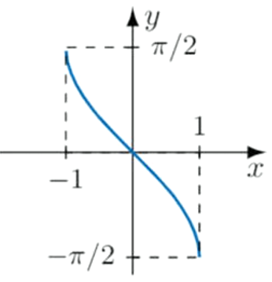  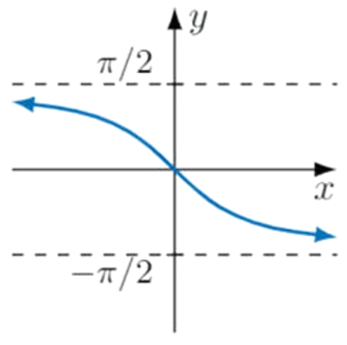 | - $y=\tan^{-1}\left(-x\right)$

- Sketch the following by first finding the domain and range.
- $y=\sin^{-1}\left(x-1\right)$ | - $y=\cos^{-1}\left(x-1\right)$  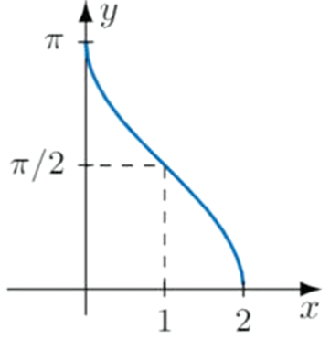 | - $y=\cos^{-1}\left(x+2\right)$  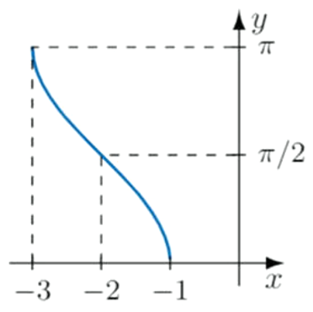  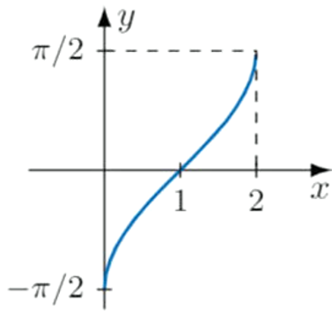
- $y=\tan^{-1}\left(x-1\right)$  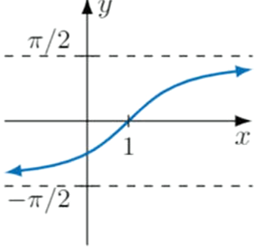 | - $y=\sin^{-1}\left(x+1\right)+\frac{π}{2}$  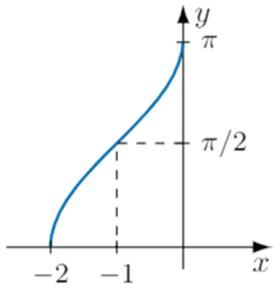 | - $y=\tan^{-1}\left(x\right)-\frac{π}{2}$  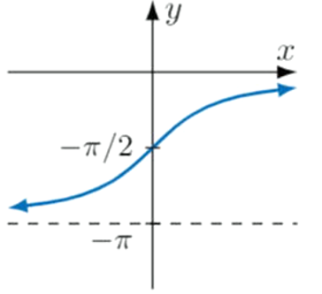

- $y=\sin^{-1}\left(2x\right)$  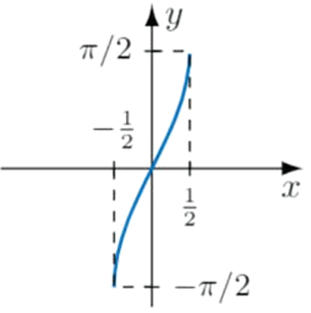 | - $y=\sin^{-1}\left(\frac{x}{2}\right)$  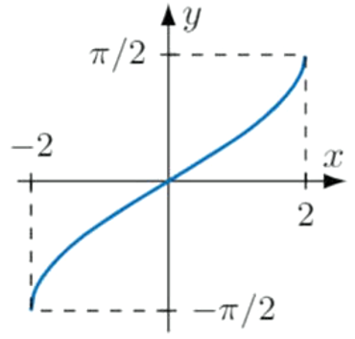 | - $y=\cos^{-1}\left(4x\right)$  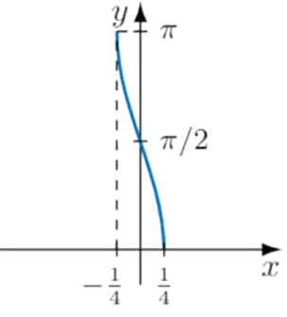
- $y=\cos^{-1}\left(\frac{x}{4}\right)$  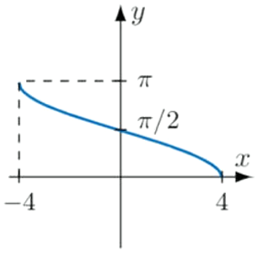 | - $y=\tan^{-1}\left(3x\right)$  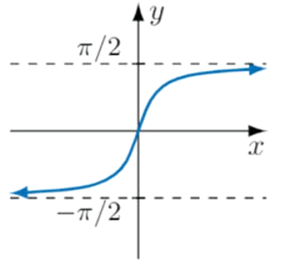 | - $y=\tan^{-1}\left(\frac{x}{3}\right)$  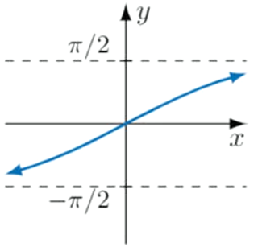

- $y=2\sin^{-1}\left(3x\right)$ | - $y=\frac{1}{2}\sin^{-1}\left(\frac{x}{4}\right)$  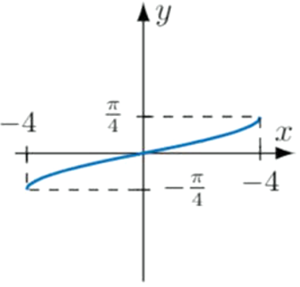 | - $y=\frac{1}{3}\cos^{-1}\left(2x\right)$  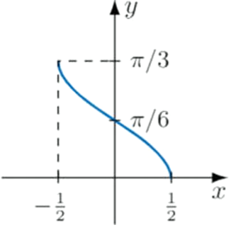  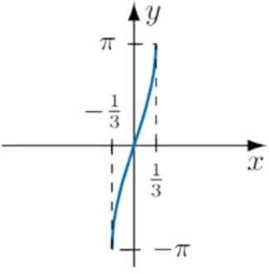
- $y=3\cos^{-1}\left(\frac{x}{4}\right)$  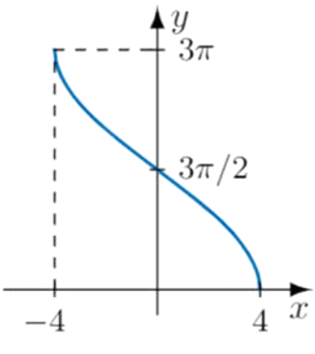  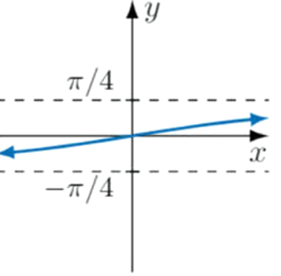 | - $y=2\tan^{-1}\left(3x\right)$  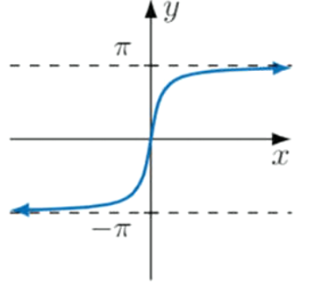 | - $y=\frac{1}{2}\tan^{-1}\left(\frac{x}{3}\right)$

- HSC Sample Question Band 4
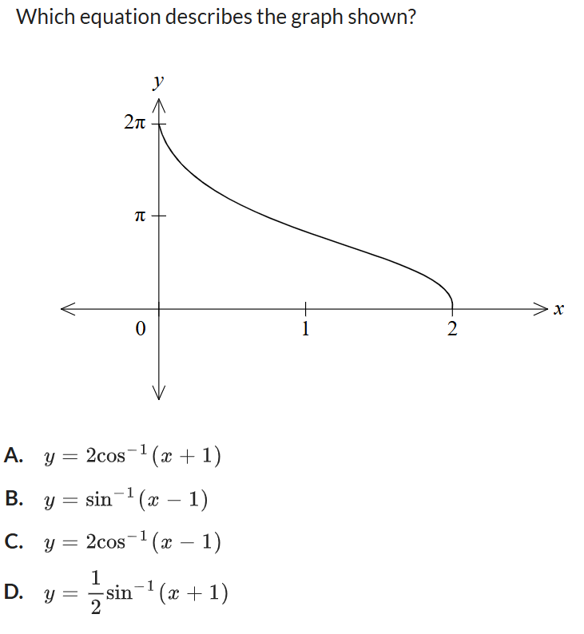
Which equation describes the graph shown?

This is an inverse cos graph,
shifted to the right by 1 and $y$ values multiplied by 2.
C

- Find a possible equation for these inverse trigonometric graphs.
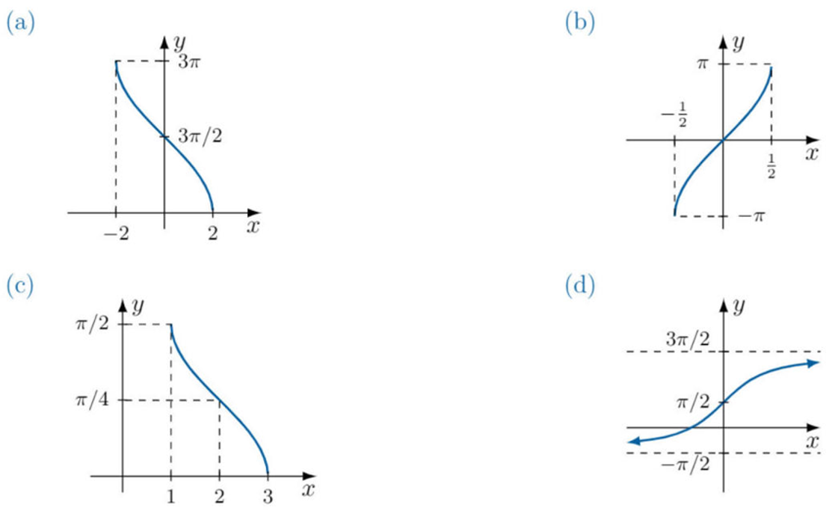  $$y=3\cos^{-1}\left(\frac{x}{2}\right)$$ | $$y=2\sin^{-1}\left(2x\right)$$
$$y=\frac{1}{2}\cos^{-1}\left(x-2\right)$$ | $$y=2\tan^{-1}\left(x\right)+\frac{π}{2}$$

Direct Composition of Inverse Trigonometric Functions

- Interpret Restrictions on $\sin\left(\sin^{-1}\left(x\right)\right)$
Consider $\sin\left(\sin^{-1}\left(x\right)\right)$.
A function and its inverse ………… each other, so you might conclude that $\sin\left(\sin^{-1}\left(x\right)\right)=$ …
Let’s investigate this using the table of values and graph below:
$$x$$ | $$\sin^{-1}{x}$$ | $$\sin\left(\sin^{-1}\left(x\right)\right)$$
$-1.5$
$-1$
$-0.5$
0
0.5
1
1.5

Complete the sentences:
The domain of $\sin^{-1}{x}$ is [……, ……], outside of this domain, $\sin^{-1}{x}$ is ……………, and therefore $\sin\left(\sin^{-1}\left(x\right)\right)$ is also …………….
However, inside the domain $[-1, 1]$, $\sin\left(\sin^{-1}\left(x\right)\right)=$ ……, as the function and its inverse undo each other.

- $sin\left(sin^{-1}\right), cos\left(cos^{-1}\right), tan\left(tan^{-1}\right)$
Inverse functions undo their original functions, but only if the original function is defined.
$\sin\left(\sin^{-1}{x}\right)=x$ for $-1≤x≤1$
$\cos\left(\cos^{-1}{x}\right)=x$ for $-1≤x≤1$
$\tan\left(\tan^{-1}{x}\right)=x$ for $x∈R$
Outside these domains, the composite functions are undefined.
Note: $\tan\left(\tan^{-1}{x}\right)$ is always defined.

- Graphs of $sin\left(sin^{-1}\right), cos\left(cos^{-1}\right), tan\left(tan^{-1}\right)$
$$f\left(x\right)=\sin\left(\sin^{-1}{x}\right)$$  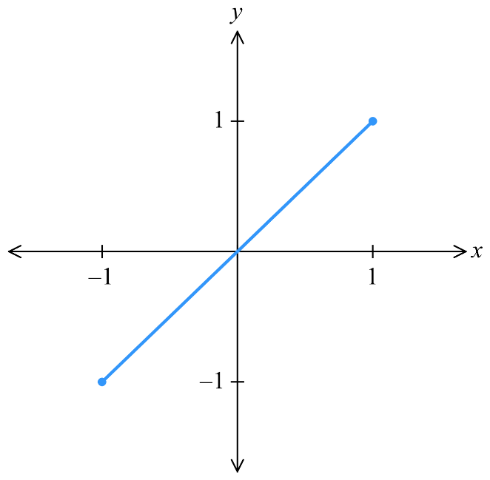  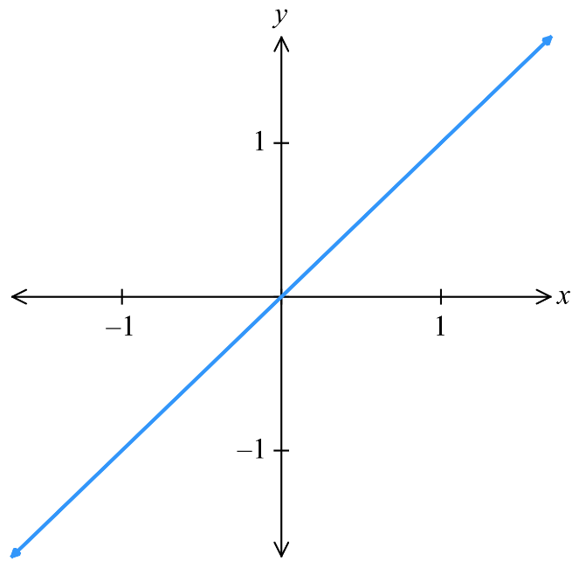  $$\sin\left(\sin^{-1}{x}\right)=x$$  for $-1≤x≤1$  undefined otherwise | $$f\left(x\right)=\cos\left(\cos^{-1}{x}\right)$$  $\cos\left(\cos^{-1}{x}\right)=x$  for $-1≤x≤1$  undefined otherwise | $$f\left(x\right)=\tan\left(\tan^{-1}{x}\right)$$  $$\tan\left(\tan^{-1}{x}\right)=x$$  for $x∈R$

- Evaluating $sin\left(sin^{-1}\left(x\right)\right), cos\left(\cos^{-1}\left(x\right)\right), tan\left(\tan^{-1}\left(x\right)\right)$
1. For $tan\left(\tan^{-1}\left(x\right)\right),$the answer is $x$.
2. For $sin\left(sin^{-1}\left(x\right)\right), cos\left(\cos^{-1}\left(x\right)\right):$
The answer is $x$ if it is within the domain $-1≤x≤1,$ otherwise it is undefined.

- Example Evaluate $sin\left(sin^{-1}\right), cos\left(cos^{-1}\right), tan\left(tan^{-1}\right)$
Find $\sin\left(\sin^{-1}{\frac{π}{3}}\right)$  $$=\frac{π}{3}$$  As $\sin\left(\sin^{-1}{x}\right)=x$ for $-1≤x≤1$ | Find $\sin\left(\sin^{-1}\left(\frac{5π}{3}\right)\right)$  This is undefined as $\sin^{-1}{x}$ is  only defined for $-1≤x≤1$

- Practice
Find $\cos\left(\cos^{-1}\left(\frac{1}{2}\right)\right)$  $$\frac{1}{2}$$ | Find $\cos\left(\cos^{-1}\left(\frac{3π}{4}\right)\right)$  Undefined as $\cos^{-1}\left(x\right)$ only defined for $-1≤x≤1$
Find $\sin\left(\sin^{-1}\left(-\frac{π}{4}\right)\right)$  $$-\frac{π}{4}$$ | Find $\tan\left(\tan^{-1}{500}\right)$  500

- Interpret Restrictions on $\sin^{-1}\left(\sin\left(x\right)\right)$
Consider $\sin^{-1}\left(\sin\left(x\right)\right)$.
$\sin\left(x\right)$ has an output between $[$…, …]; This means $\sin^{-1}\left(\sin\left(x\right)\right)$ is always defined.
A function and its inverse ………… each other, so you might conclude that $\sin^{-1}\left(\sin\left(x\right)\right)=$ …
Let’s investigate this using the table of values and graph below:
$$x$$ | $$sin x$$ | $$\sin^{-1}\left(\sin\left(x\right)\right)$$
0
$$\frac{π}{6}$$
$$\frac{π}{3}$$
$$\frac{π}{2}$$
$$\frac{2π}{3}$$
$$\frac{5π}{6}$$
$$π$$
$$\frac{7π}{6}$$
$$\frac{4π}{3}$$
$$\frac{3π}{2}$$
$$\frac{5π}{3}$$
$$\frac{11π}{6}$$
$$2π$$
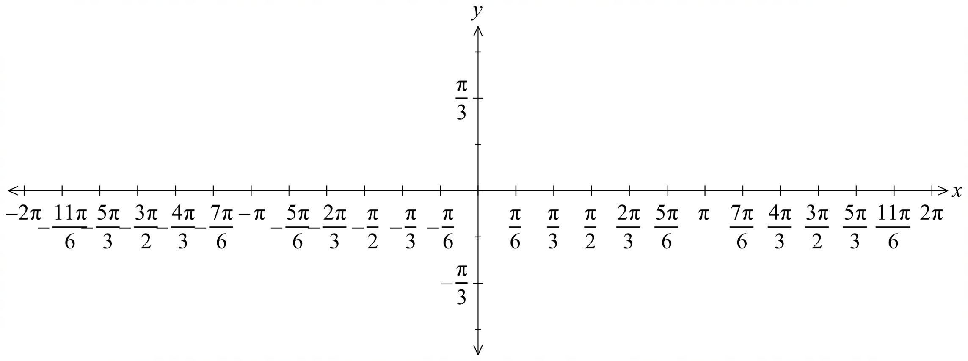

If $f\left(x\right)$ is odd and $g\left(x\right)$ is odd, then $f\left(g\left(x\right)\right)$ is odd (you proved this in the composite functions booklet).
Therefore, complete the negative side of $y=\sin^{-1}\left(\sin\left(x\right)\right)$.
- $sin^{-1}\left(sin\right), cos^{-1}\left(cos\right), tan^{-1}\left(tan\right)$
$\sin^{-1}\left(\sin{x}\right)=x$ for $-\frac{π}{2}≤x≤\frac{π}{2}$
$\cos^{-1}\left(\cos{x}\right)=x$ for $0≤x≤π$
$\tan^{-1}\left(\tan{x}\right)=x$ for $-\frac{π}{2}≤x≤\frac{π}{2}$
These inverse trigonometric functions accept any angle as input, but they only output values in the range of the outer function.

- Graphs of $sin^{-1}\left(sin\right), cos^{-1}\left(cos\right), tan^{-1}\left(tan\right)$
$$f\left(x\right)=\sin^{-1}\left(\sin{x}\right)$$  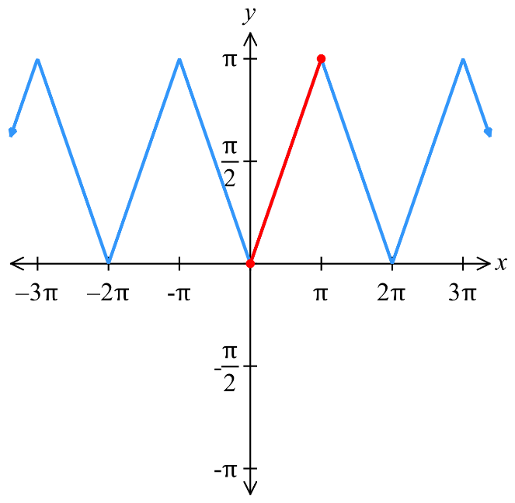  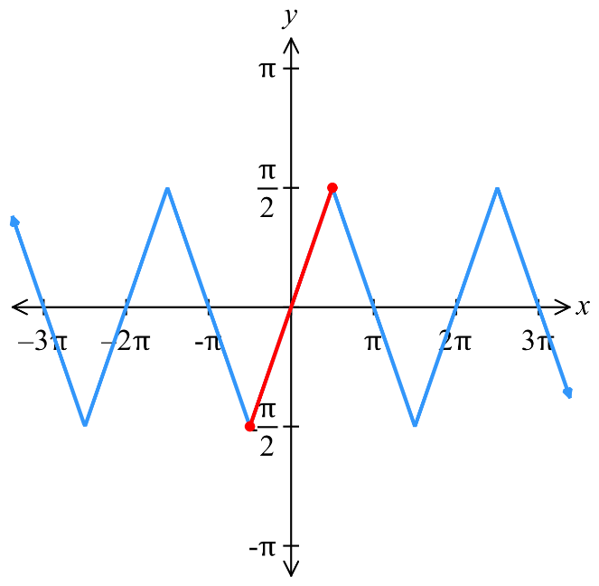  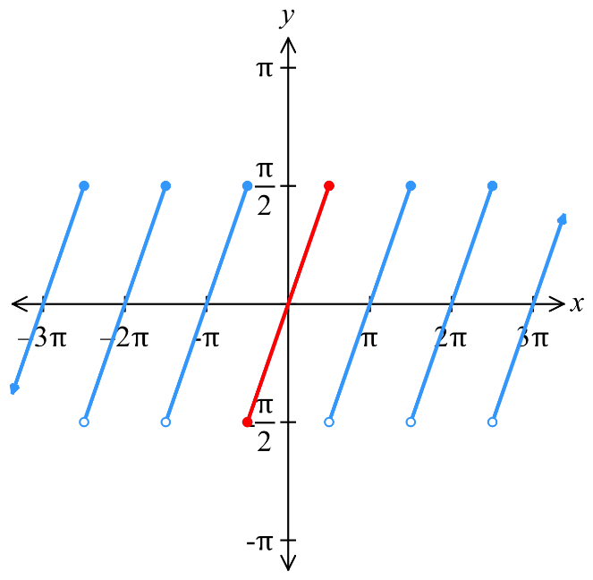  $\sin^{-1}\left(\sin{x}\right)=x$  for $-\frac{π}{2}≤x≤\frac{π}{2}$ | $$f\left(x\right)=\cos^{-1}\left(\cos{x}\right)$$  $\cos^{-1}\left(\cos{x}\right)=x$  for $0≤x≤π$ | $$f\left(x\right)=\tan^{-1}\left(\tan{x}\right)$$  $$\tan^{-1}\left(\tan{x}\right)=x$$  for $-\frac{π}{2}<x<\frac{π}{2}$
Outside these domains, these functions output the equivalent angle within their range.

- Direct compositions can all be evaluated on your calculator.
Make sure you're in radians mode.
E.g. $\cos^{-1}\left(\cos{\frac{5π}{4}}\right)=\frac{5π}{4}$ in degrees mode ✖
$\cos^{-1}\left(\cos{\frac{5π}{4}}\right)=\frac{3π}{4}$ in radians mode ✔

- Evaluating $sin^{-1}\left(sin\left(x\right)\right), cos^{-1}\left(cos\left(x\right)\right), tan^{-1}\left(tan\left(x\right)\right)$
$\sin^{-1}\left(\sin{x}\right)=x$ for $-\frac{π}{2}≤x≤\frac{π}{2}$
$\cos^{-1}\left(\cos{x}\right)=x$ for $0≤x≤π$
$\tan^{-1}\left(\tan{x}\right)=x$ for $-\frac{π}{2}≤x≤\frac{π}{2}$
If $x$ is outside the given domain, find the equivalent angle within the given range:
1. Determine the reference angle.
2. Find the equivalent angle within the range, remember to check the sign.
For $\sin^{-1}\left(\sin{x}\right),$ $-\frac{π}{2}≤x≤\frac{π}{2}$ (Q1, Q4)
For $\cos^{-1}\left(\cos{x}\right),$ $0≤x≤π$ (Q1, Q2)
For $\tan^{-1}\left(\tan{x}\right)$, $-\frac{π}{2}≤x≤\frac{π}{2}$ (Q1, Q4)
3. Rewrite the inner trig function with the equivalent angle.
4. Evaluate using the identities above.

- Example Evaluate the direct composition of a trigonometric function.
Find $\sin^{-1}\left(\sin{\frac{π}{3}}\right)$  $$=\frac{π}{3}$$  As $\sin^{-1}\left(\sin{x}\right)=x$ for $-\frac{π}{2}$ $≤x≤$ $\frac{π}{2}$ | Find $\sin^{-1}\left(\sin{\frac{5π}{3}}\right)$  1. For $θ=\frac{5π}{3},$ reference angle $A=\frac{π}{3}$  2. Want $\left[-\frac{π}{2},\frac{π}{2}\right]$; $\sin\left(\frac{5π}{3}\right)<0$, so Q4  3. $\sin{\frac{5π}{3}}=\sin\left(-\frac{π}{3}\right)$  4. $∴\sin^{-1}\left(\sin\left(-\frac{π}{3}\right)\right)=-$ $\frac{π}{3}$

- Practice
Find $\sin\left(\sin^{-1}{\frac{π}{4}}\right)$  $$\frac{π}{4}$$ | Find $\cos^{-1}\left(\cos{\frac{3π}{4}}\right)$  $$\frac{3π}{4}$$
Find $\cos^{-1}\left(\cos{\frac{5π}{4}}\right)$  $$\frac{3π}{4}$$ | Find $\tan^{-1}\left(\tan{\frac{7π}{4}}\right)$  $$-\frac{π}{4}$$

Foundation
- Evaluate:
- $\sin^{-1}\left(sin\left(\frac{π}{5}\right)\right)$  $$\frac{π}{5}$$ | - $\cos^{-1}\left(cos\left(\frac{3π}{5}\right)\right)$  $$\frac{3π}{5}$$
- $cos\left(arccos\left(-\frac{1}{2}\right)\right)$  $$-\frac{1}{2}$$ | - $\sin\left(\sin^{-1}\left(\frac{6π}{5}\right)\right)$  undefined
- $\sin{(\arcsin{1)}}$  $$1$$ | - $\tan\left(\arctan\left(-\frac{3}{5}\right)\right)$  $$-\frac{3}{5}$$
- $\tan^{-1}\left(tan\left(\frac{π}{7}\right)\right)$  $$\frac{π}{7}$$ | - $\tan\left(\tan^{-1}\left(3π\right)\right)$  $$3π$$

  - Explain why $\sin^{-1}\left(\sin{\frac{5π}{3}}\right)≠\frac{5π}{3}.$

The range of sin⁻¹ is $\left[-\frac{π}{2},\frac{π}{2}\right]$, but $\frac{5π}{3}∉ \left[-\frac{π}{2},\frac{π}{2}\right]$.
Since $\frac{5π}{3}$ is outside the range of sin⁻¹, it cannot equal $sin^{-1}\left(sin\left(\frac{5π}{3}\right)\right).$
  - What condition must $x$ meet for $\sin^{-1}\left(\sin{x}\right)=x$?

Since $\sin^{-1}{x}∈\left[-\frac{π}{2},\frac{π}{2}\right],$then $x∈\left[-\frac{π}{2},\frac{π}{2}\right]$
  - Describe how to evaluate $\sin^{-1}\left(\sin{\frac{5π}{3}}\right)$.

Find the angle equivalent to $\frac{5π}{3}$ in the domain $\left[-\frac{π}{2},\frac{π}{2}\right]$
Then use the identity $\sin^{-1}\left(\sin{x}\right)=x$
$$Since \sin\left(\frac{5π}{3}\right)=\sin\left(-\frac{π}{3}\right)$$
$$\sin^{-1}\left(\sin{\frac{5π}{3}}\right)=\sin^{-1}\left(\sin\left(-\frac{π}{3}\right)\right)=-\frac{π}{3}$$

Development
- Evaluate:
- $\sin^{-1}\left(sin\left(\frac{4π}{3}\right)\right)$  $$sin\left(\frac{4π}{3}\right)=\sin\left(-\frac{π}{3}\right)$$  $$\sin^{-1}\left(\sin\left(-\frac{π}{3}\right)\right)= -\frac{π}{3}$$ | - $\cos^{-1}\left(cos\left(-\frac{π}{4}\right)\right)$  $$cos\left(-\frac{π}{4}\right)=\cos{\frac{π}{4}}$$  $$\cos^{-1}\left(\cos{\frac{π}{4}}\right)=\frac{π}{4}$$
- $\tan^{-1}\left(tan\left(\frac{5π}{6}\right)\right)$  $$tan\left(\frac{5π}{6}\right) =\tan\left(-\frac{π}{6}\right)$$  $$\tan^{-1}\left(\tan\left(-\frac{π}{6}\right)\right)= -\frac{π}{6}$$ | - $\cos^{-1}\left(cos\left(\frac{5π}{4}\right)\right)$  $$cos\left(\frac{5π}{4}\right)= cos\left(\frac{3π}{4}\right)$$  $$\cos^{-1}\left(cos\left(\frac{5π}{4}\right)\right)=\frac{3π}{4}$$
- $\cos^{-1}\left(\cos\left(-\frac{π}{7}\right)\right)$  $$\cos\left(-\frac{π}{7}\right)=\cos\left(\frac{π}{7}\right)$$  $$\cos^{-1}\left(\cos\left(\frac{π}{7}\right)\right)= \frac{π}{7}$$ | - $\sin^{-1}\left(sin\left(\frac{6π}{5}\right)\right)$  $$sin\left(\frac{6π}{5}\right) = sin\left(-\frac{π}{5}\right)$$  $$\sin^{-1}\left(sin\left(-\frac{π}{5}\right)\right) = -\frac{π}{5}$$

- For these questions, it is not possible to use the identity $\sin^{-1}\left(\sin{x}\right)=x$, so you must evaluate the inner function first.
- $arcsin\left(2sin\left(-\frac{π}{6}\right)\right)$  $$sin\left(-\frac{π}{6}\right)= -\frac{1}{2}$$  $$2sin\left(-\frac{π}{6}\right)= -1$$  $$arcsin(-1) = -\frac{π}{2}$$ | - $arctan\left(3tan\left(\frac{7π}{6}\right)\right)$  $$tan\left(\frac{7π}{6}\right)= tan\left(\frac{π}{6}\right)=\frac{1}{\sqrt{3}}$$  $$3tan\left(\frac{7π}{6}\right)= 3\left(\frac{1}{\sqrt{3}}\right)= \sqrt{3}$$  $$arctan\left(\sqrt{3}\right)=\frac{π}{3}$$

- 2022 HSC Extension 1 Band 4
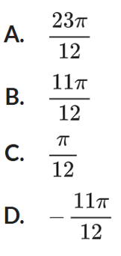
Given that $\cos\left(\frac{23π}{12}\right)=$ $\frac{\sqrt{6}+\sqrt{2}}{4}$, which of the following is the value of $\cos^{-1}\left(\frac{\sqrt{6}+\sqrt{2}}{4}\right)$?

$$\cos^{-1}\left(\frac{\sqrt{6}+\sqrt{2}}{4}\right)=\cos^{-1}\left(\cos{\frac{23π}{12}}\right)$$
$$=\cos^{-1}\left(\cos{\frac{π}{12}}\right)$$
$$=\frac{π}{12}$$
C
- 2023 HSC Extension 1 Band 4
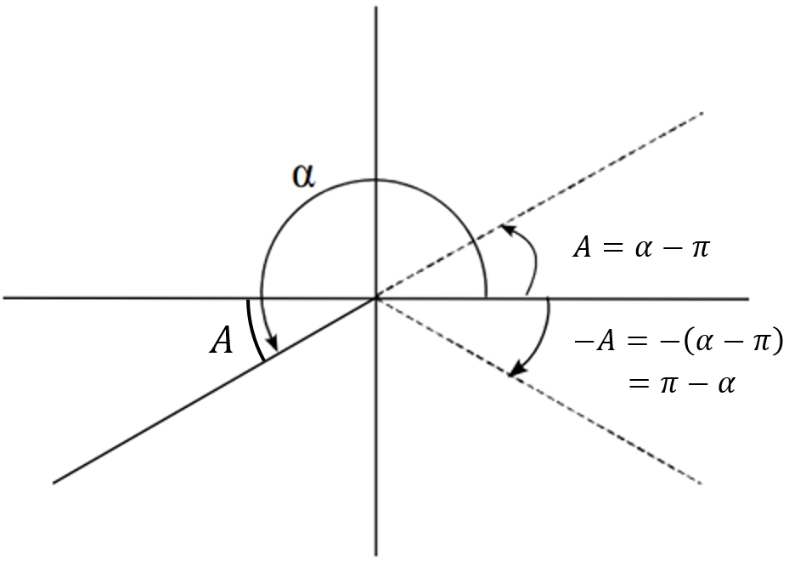
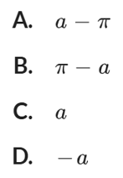
Which of the following is the value of $\sin^{-1}\left(\sin{α}\right)$ given $π<α<$ $\frac{3π}{2}$?
$α$ is in Q3, so sin $α$ is negative.
We want sin to be in $\left[-\frac{π}{2},\frac{π}{2}\right]$, so Q1 and Q4
Since sin $α$ is negative, we want the angle in Q4

$α$ is obtuse, let the reference angle be $A$; so $A=α-π$
The equivalent angle in Q4 is $-A=π-α$
B

- 2019 HSC Extension 1 Band 4
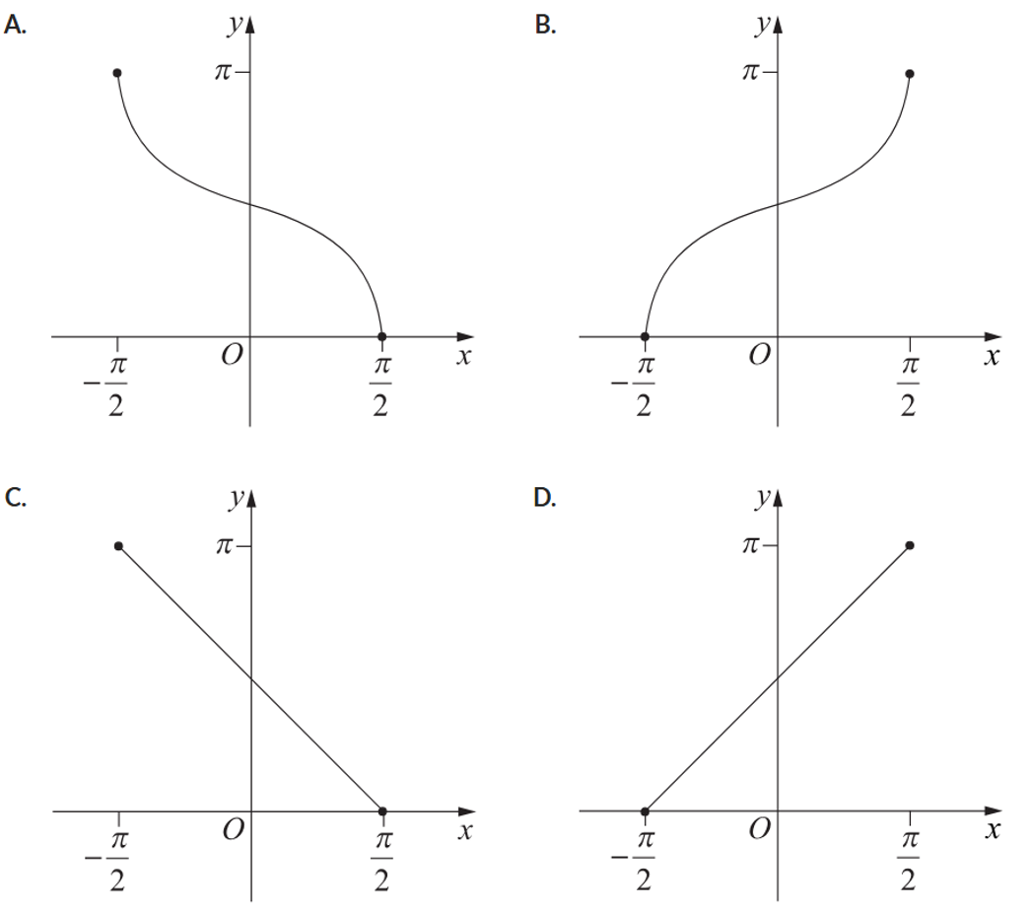
Which graph best represents $y=\cos^{-1}\left(-\sin{x}\right)$ for $-\frac{π}{2}≤x≤\frac{π}{2}$?

$$\cos^{-1}\left(-\sin{x}\right)$$
$$using\sin{x}=\cos\left(\frac{π}{2}-x\right):$$
$$=\cos^{-1}\left(-\cos\left(\frac{π}{2}-x\right)\right)$$
$$using-\cos{x}=\cos{(π-x}):$$
$$=\cos^{-1}\left(\cos\left(π-\left(\frac{π}{2}-x\right)\right)\right)$$
$$=\cos^{-1}\left(\cos\left(\frac{π}{2}+x\right)\right)$$
$$=\frac{π}{2}+x$$
D

- Solve $\cos^{-1}{x}=\sin^{-1}\left(-\frac{5}{13}\right)$ for $x$.

$\sin^{-1}\left(-\frac{5}{13}\right)$ is an angle in Q4, and since $-\frac{π}{2}≤\sin^{-1}{θ}≤\frac{π}{2}$, it is negative.
But $0≤\cos^{-1}{θ}≤π$
So, there is no solution.

Applications involving Double and Compound Angles

- Compound and Double Angle Identities
$$\sin\left(A+B\right)=\sin{A}\cos{B}+\cos{A}\sin{B}$$  $$\cos\left(A+B\right)=\cos{A}\cos{B}-\sin{A}\sin{B}$$  $$\tan\left(A+B\right)=\frac{\tan{A}+\tan{B}}{1-\tan{A}\tan{B}}$$ | $$\sin\left(2θ\right)=2\sin{θ}\cos{θ}$$  $$\cos\left(2θ\right)=\cos^{2}{θ}-\sin^{2}{θ}$$  $$\tan\left(2θ\right)=\frac{2\tan{θ}}{1-\tan^{2}{θ}}$$

Foundation
- Consider $\cos\left(2\sin^{-1}\left(\frac{4}{5}\right)\right)$.
  - Let $A=\sin^{-1}\left(\frac{4}{5}\right)$. Show that the expression is equivalent to $1-2\sin^{2}{A}.$
$$cos\left(2\sin^{-1}\left(\frac{4}{5}\right)\right)= cos\left(2A\right)$$
$$= 1 - 2sin²A$$
  - Write down the value of $\sin{A}$
$$sin A =\sin\left(\sin^{-1}{\frac{4}{5}}\right)=\frac{4}{5}$$
  - Hence, find the exact value of $\cos\left(2\sin^{-1}\left(\frac{4}{5}\right)\right)$.
$$cos\left(2\sin^{-1}\left(\frac{4}{5}\right)\right)=1 - 2sin²A$$
$$= 1 - 2{\left(\frac{4}{5}\right)}^{2}$$
$$= -\frac{7}{25}$$
- Use a similar method to above to find the exact value of:
- $\sin\left(2\cos^{-1}\left(\frac{3}{5}\right)\right)$  $$Let A = \cos^{-1}\left(\frac{3}{5}\right), so cos A =\frac{3}{5}$$  $$Using sin\left(2A\right)= 2sin A cos A$$  $$From right triangle: sin A =\frac{4}{5}$$  $$sin\left(2\cos^{-1}\left(\frac{3}{5}\right)\right)= 2\left(\frac{4}{5}\right)\left(\frac{3}{5}\right)=\frac{24}{25}$$ | - $\sin\left(2\tan^{-1}\left(\sqrt{3}\right)\right)$  $$Let A = \tan^{-1}\left(\sqrt{3}\right), so tan A = \sqrt{3}$$  $$This means A =\frac{π}{3}, so sin A =\frac{\sqrt{3}}{2}, cos A =\frac{1}{2}$$  $$Using sin\left(2A\right)= 2sin A cos A$$  $$sin\left(2\tan^{-1}\left(\sqrt{3}\right)\right)= 2\left(\frac{\sqrt{3}}{2}\right)\left(\frac{1}{2}\right)=\frac{\sqrt{3}}{2}$$
- $\cos\left(2\tan^{-1}\left(\frac{2}{3}\right)\right)$  $$Let A = \tan^{-1}\left(\frac{2}{3}\right), so tan A =\frac{2}{3}$$  $$From right triangle: opposite = 2, adjacent = 3, hypotenuse = \sqrt{13}$$  $$So sin A =\frac{2}{\sqrt{13}}, cos A =\frac{3}{\sqrt{13}}$$  $$Using cos\left(2A\right)= \cos^{2}A - \sin^{2}A$$  $$cos\left(2\tan^{-1}\left(\frac{2}{3}\right)\right)= {\left(\frac{3}{\sqrt{13}}\right)}^{2}- {\left(\frac{2}{\sqrt{13}}\right)}^{2}=\frac{9}{13}-\frac{4}{13}=\frac{5}{13}$$ | - $\tan\left(2\sin^{-1}\left(\frac{1}{3}\right)\right)$  $$Let A = \sin^{-1}\left(\frac{1}{3}\right), so sin A =\frac{1}{3}$$  $$From right triangle: cos A = 2\frac{\sqrt{2}}{3}$$  $$Using tan\left(2A\right)= \frac{2tanA}{1 - \tan^{2}A}$$  $$tan A = sin\frac{A}{cos}A =\frac{\frac{1}{3}}{\frac{2\sqrt{2}}{3}}=\frac{1}{2\sqrt{2}}=\frac{\sqrt{2}}{4}$$  $$tan\left(2\sin^{-1}\left(\frac{1}{3}\right)\right)=\frac{2\left(\frac{\sqrt{2}}{4}\right)}{1 - {\left(\frac{\sqrt{2}}{4}\right)}^{2}}=\frac{\frac{\sqrt{2}}{2}}{1 -\frac{2}{16}} =\frac{\frac{\sqrt{2}}{2}}{\frac{14}{16}} = \frac{4\sqrt{2}}{7}$$

- Consider the expression $\tan\left(\sin^{-1}\left(\frac{12}{13}\right)-\cos^{-1}\left(\frac{4}{5}\right)\right)$
Let $A=\sin^{-1}\left(\frac{12}{13}\right)$and $B=\cos^{-1}\left(\frac{4}{5}\right)$
  - Use compound angle rule to write the expression in terms of $A$ and $B$ and expand.

$$\tan\left(A-B\right)=\frac{\tan{A}-\tan{B}}{1+\tan{A}\tan{B}}$$
  - By drawing appropriate triangles, find $\tan{A}$and $\tan{B}$.

$$\tan{A}=\frac{12}{5},\tan{B}=\frac{3}{4}$$
  - Use your values from b to find the exact value of $\tan\left(\sin^{-1}\left(\frac{12}{13}\right)-\cos^{-1}\left(\frac{4}{5}\right)\right)$.

$$\tan\left(\sin^{-1}\left(\frac{12}{13}\right)-\cos^{-1}\left(\frac{4}{5}\right)\right)=\frac{\tan{A}-\tan{B}}{1+\tan{A}\tan{B}}$$
$$=\frac{\frac{12}{5}-\frac{3}{4}}{1+\frac{12}{5}×\frac{3}{5}}$$
$$=\frac{33}{56}$$

Development
- 2012 HSC Extension 1 Band 4
Write $\sin\left(2\cos^{-1}\left(\frac{2}{3}\right)\right)$ in the form $a\sqrt{b}$ where $a$ and $b$ are rational.
Let $A=\cos^{-1}{\frac{2}{3}}$
$$\cos{A}=\frac{2}{3}$$
Using a right-angled triangle:
$$\sin{A}=\frac{\sqrt{5}}{3}$$
$$\sin\left(2\cos^{-1}\left(\frac{2}{3}\right)\right)=\sin{2A}$$
$$=2\sin{A}\cos{A}$$
$$=2×\frac{\sqrt{5}}{3}×\frac{2}{3}$$
$$=\frac{4}{9}\sqrt{5}$$

- HSC Extension 1 Sample Question Band 4
Find $\sin{θ}$ given that $θ=\arccos\left(\frac{12}{13}\right)+\arctan\left(\frac{3}{4}\right)$ and $0≤θ≤\frac{π}{2}$

$$Let A=\cos^{-1}{\frac{12}{13}}, B=\tan^{-1}{\frac{3}{4}}$$
$$\cos{A}=\frac{12}{13}, \tan{B}=\frac{3}{4}$$

$$\sin{θ}=\sin\left(\arccos\left(\frac{12}{13}\right)+\arctan\left(\frac{3}{4}\right)\right)$$
$$=\sin\left(A+B\right)$$
$$=\sin{A}\cos{B}+\sin{B}\cos{A}$$
Using right-angled triangles,
$$=\frac{5}{13}×\frac{4}{5}+\frac{3}{5}×\frac{12}{13}$$
$$=\frac{56}{65}$$

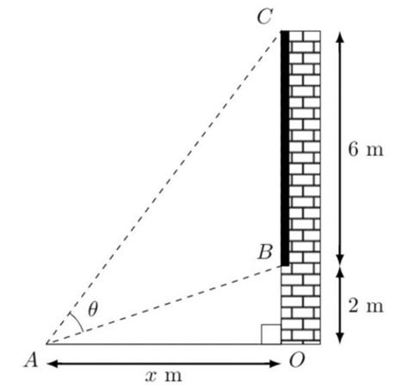
- A person stands $x$ metres away from a 6-metre-tall billboard placed 2 metres above the ground as shown.
The viewing angle $θ$ is the difference in angle of elevation from the observer to the top and the base of the billboard.
Show that $θ=\tan^{-1}\left(\frac{6x}{x^{2}+16}\right)$

$$Let α = angle of elevation to top of billboard$$
$$Let β = angle of elevation to base of billboard$$
$$tan α =\frac{8}{x}$$
$$tan β =\frac{2}{x}$$
$$viewing angle θ = α - β$$
$$tan θ =tan\left(α - β\right)=\frac{tan α - tan β}{1 + tan α tan β}$$
$$tan θ =\frac{\frac{8}{x}-\frac{2}{x}}{1 + \left(\frac{8}{x}\right)\left(\frac{2}{x}\right)}$$
$$=\frac{\frac{6}{x}}{1 +\frac{16}{x^{2}}}$$
$$=\frac{\frac{6}{x}}{\frac{x^{2}+ 16}{x^{2}}}$$
$$= \left(\frac{6}{x}\right)× \left(\frac{x^{2}}{x^{2}+ 16}\right)$$
$$=\frac{6x}{x^{2}+ 16}$$
$$Therefore: θ = \tan^{-1}\left(\frac{6x}{x^{2}+ 16}\right)$$

